Life Changing Truth

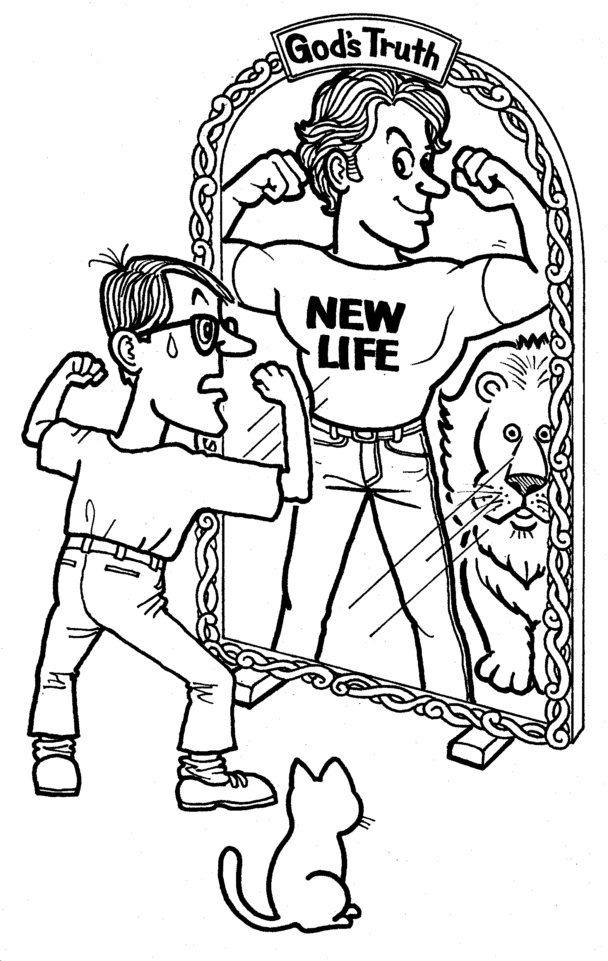

An Introduction to the Christian Faith
(Teacher’s Edition)

English and Japanese

Mike McGinty
An Introduction to the Christian Faith
(Teacher’s Edition)

Revised June 2003

LIFE
CHANGING
TRUTH

Mike McGinty

translation by Kayoko Ishiie

illustrations by Shuichi Ueno

layout by Irene Hope

All Scripture references are from the New American Standard Version.

OMF International
1-16-14 Shinden,
Ichikawa Shi, Chiba Ken 272-0035
 (047) 324-3221

Life-Changing Truth

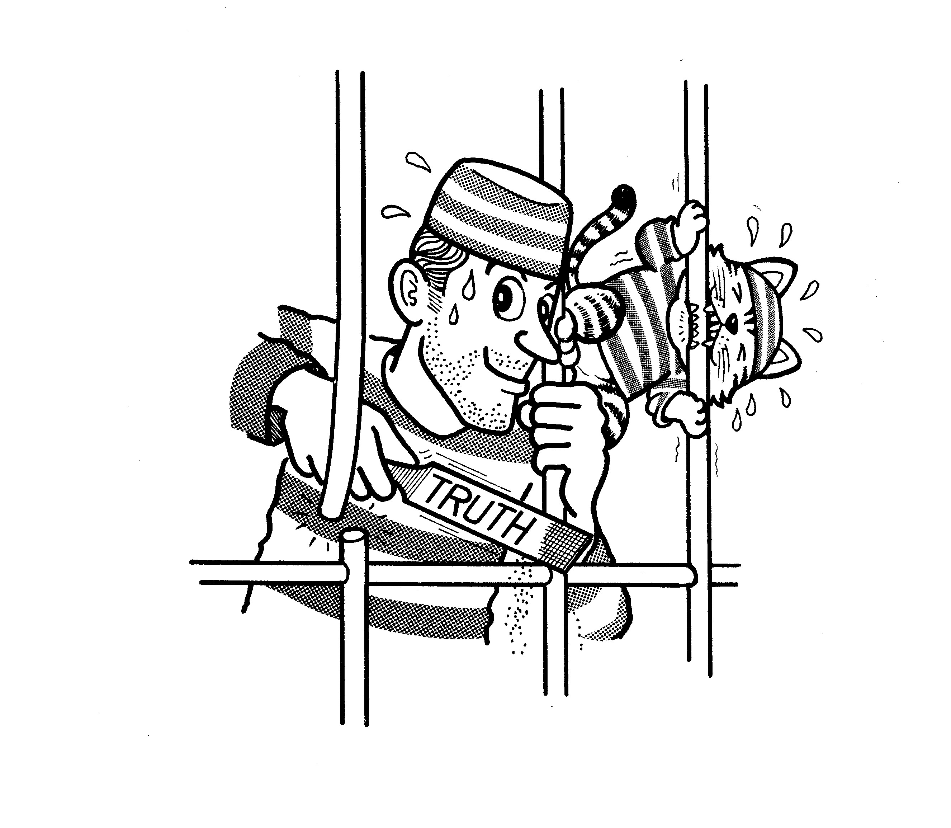
Introduction

Nearly 2,000 years ago, a Roman governor by the name of Pontius Pilate asked the rhetorical question “What is truth” when confronted with a difficult decision. This was a very important question as Pilate was about to decide the fate of a very unique man by the name of Jesus. In the end, Pilate ignored the truth about Jesus. Instead, he decided to have Jesus executed as a common criminal, even though Pilate admitted that Jesus was innocent of any crimes.

Jesus often taught about truth and on one occasion said “You shall know the truth and the truth shall set you free.” Today and over the centuries, millions of people, known as “Christians”, testify how the truth about Jesus and the truth taught by Him have set them free. Instead of being behind bars of steel, they were imprisoned by bars of sin and selfishness. Such ‘bars’ had negatively affected their relationships with other people and more importantly, their relationship with the God who created them. However, many lives and families have been changed by these God-given truths that can set us free. These truths are ancient, but unchangeable and eternal in value.

Where is this truth to be found? What are the basic truths you should know? How will such truth affect you personally? Over the next few weeks through a series of ten lessons, we will study the Bible and discover God’s eternal truths that can change your life forever.

Table of Contents

Study Guide Notes i

Lesson 1: “The Eternal Bestseller”

The Source of Truth: The Bible: “Thy Word is truth 1

Lesson 2: “Beginning with God”

The Truth about God Part One 4

Lesson 3: “Eternal Treasure”

The Truth about God Part Two 8
Lesson 4: “The Game of Life”

The Truth about Man Part One 12

Lesson 5: “Weeds in God’s Garden”

The Truth about Man Part Two 16
Lesson 6: “God’s Christmas Gift”

The Truth about Jesus Part One: “I am the Truth” 20

Lesson 7: “Mystery Clues”

The Truth about Jesus Part Two 24
Lesson 8: “History and the Cross”

The Truth about Jesus Part Three 29
Lesson 9: “God’s Path”

The Truth about Salvation 34

Lesson 10: “The Tightrope of Life”

The Truth and You 39

Appendix i

Study Guide Notes

INTRODUCTION

The theme of truth has been woven throughout this Bible study as it is generally a neutral term and also because most people tend to recognize the need for truth in their lives. Therefore, rather than presenting Christianity as a religion, people need to be challenged with the truths of God’s Word, which can change their lives both eternally and immediately. A person who seeks after God will also seek truth.

With this in mind, this Bible study follows a logical procession of essential truths that serve as stepping-stones leading to salvation. It begins with the Bible (Lesson 1), which needs to be presented and recognized as the source of truth. Otherwise, the remaining lessons (2-10) risk being erroneously received as only the personal opinions of the teacher, the traditions of men, or just another religious moral code. The Bible is the real textbook the student will be using so it is essential they appreciate its importance from the very beginning. Lessons 2-3 communicate truths about God that will help the student understand what God expects from us. The truths about man in Lessons 4-5 then reveal how man fails to live up to these expectations. This highlights his need for a Savior, who is introduced in Lessons 6-8. The final two lessons then serve to personalize the Bible study for the student, emphasizing the need to respond to God’s truth so that it may indeed change his life. Therefore, this Bible study is titled “Life Changing Truth”.

Another purpose of this Bible study is to systematically get the student into God’s Word (Hebrews 4:12) and allow for the Holy Spirit to bring conviction of sin and repentance, rather than relying on cleverly worded arguments. Therefore, considerable thought has been given to the Bible passages to be used in this study. Longer passages, which touch on a number of essential truths, have been chosen over isolated verses as this encourages a greater depth of interaction between the student and God’s Word. Of course this does not prevent the teacher from using other passages at his discretion to

i
reinforce a particular point. However, caution should be exercised in using passages that may introduce subjects or issues that can distract the student from the central truths related to salvation, which is where you want the student to stay focused.

This study is in an English/Japanese format to help missionaries whose first language is not Japanese, and to make it a useable tool for those involved in English teaching. Furigana is also included for the same reason.

HOW YOU START AN EVANGELISTIC BIBLE STUDY

The hardest part in studying the Bible with a non-Christian is often not in studying the Bible itself but in actually initializing the Bible study! How can we get our unbelieving friend or relative to agree to study the Bible with us?

Obviously, we begin with prayer, asking God to help in the process by preparing the person’s heart. Then we must look for and possibly even create opportunities to boldly invite the person we’ve been praying for to join us in a study. (Matt. 7:7-8) All such invitations of course must be grounded in the trust relationship that you have hopefully already established with your friend or relative. People are more inclined to want to know and trust your God because they know and trust you.

But what are some practical questions you might use as an invitation to join a Bible study when the opportunity does arise? Below are a few suggestions, but certainly there are many other possible approaches you can use. Of course the one you use should be appropriate to the person and situation you are in. Ask God to guide you as to what you should say. (Matt.10:18-20)

- Would you like to know more about Christianity and why I became a Christian?
- Would you like to know how Christianity is different from other world religions?
- Would you like to know more about God and how much He loves you?

ii
- Would you like to know more about the Bible and its basic teachings?
- Are you looking for meaning and direction in your life?
- Did you know that the Bible is like a manual that can help us with everyday issues in life? Would you like to know more about it?
- What are you living for? What should you live for? What does the Bible teach about this?
- Would you like to know how to have eternal life and forgiveness of sin?
- Did you know that God offers rest to those who are tired? (Matt.11:28) Would you like to know more about this rest?

If you receive a positive answer to any of the previous or similar questions, you might want to follow it up in the following way:

“If you are interested, I would be delighted to meet with you ten times to study the Bible using this textbook. (show textbook) There is no pressure for you to become a Christian, be baptized, attend church, give money, etc. Of course, because I care for you, I want you to receive the blessing of knowing God as I have but that is for you to decide. Jesus said “You shall know the truth and the truth shall set you free.” I hope we can study together some of the eternal truths recorded in the Bible that changed my life.“

BEFORE YOU START

Atmosphere is an important element to your Bible study that can either hinder or enhance your efforts. Choose a location and time that will facilitate your student’s ability to relax and encourage active participation. Small talk and light refreshments may help to put the student at ease and other activities with the student outside of scheduled class times can be instrumental in earning his trust. Offer to pray for your student either before or at the end of the class with regard to any specific needs they may have. As the students grow in their awareness of your genuine concern for them, they will be more likely to

iii
receive what you have to say. Instead of a classroom or school-like setting, you want to establish an atmosphere that encourages openness in sharing without fear of making mistakes.

If you are teaching more than one person at a time, it is important to create an environment of mutual trust among your students so that they will feel free to share matters of the heart later on in the study. Icebreakers are provided for each lesson with this purpose in mind. More time may need to be devoted to this in the first few lessons as you seek to bond as a group. This is why the initial lessons are shorter than those toward the end of the series.

It is also important to respect your student’s time by making every effort to start and end the study on time. If the student has additional questions that are unrelated to that day’s lesson, seek to answer the questions afterwards so that the choice to remain for an extended time of study is the student’s own and not forced upon him. Each lesson is designed to be completed roughly within an hour but you may want to lengthen or shorten that time according to your particular circumstances. Whatever you decide, be sure the projected length of your study time is clearly communicated to the student so he can plan accordingly. Respect for their time may help to earn their respect for what you have to say in the course of the study.

WHO CAN USE THIS STUDY

God can use any Christian to lead others to Christ (II Corinthians 4:7) so this Bible study can be used by even the newest of believers. In fact, they are encouraged to do so! A new Christian’s faith and enthusiasm can compensate for what they may lack in knowledge or experience. However, a new believer is certainly to be encouraged to get advice from a more mature Christian or church leader in areas where they may need help.

Prayer is an essential element to any Bible study as it is the Holy Spirit alone who can open people’s hearts to understanding the truth. God is the ultimate teacher so our absolute dependence upon Him in prayer is where we must
always begin. Prayer and preparation must go hand in hand. Never neglect to pray for your student and yourself.

iv
As you communicate the truths of God’s Word to your friend or relative, always remember that he or she is a unique person with unique questions, fears, doubts and concerns. Although you cannot possibly understand all that is in someone else’s heart, it is helpful to constantly recall how you once thought as a non-Christian. As you teach the Word of God, you want to make it understandable and relevant to the student. Where appropriate, share your own struggles in becoming a Christian and how God enabled you to overcome them.

HOW TO USE THIS STUDY

This Bible study series only provides a framework that each teacher will need to build upon and personalize with his own comments, illustrations, Bible passages or personal experiences. Although some illustrations and key teaching points are included in the appendix, the goal is for the student to discover Biblical truths for himself and for you as the teacher to assist him to that end. Therefore, your contributions are important, as the most effective type of evangelistic Bible study is one that is built upon and born out of a personal relationship. Don’t underestimate the contribution you are able to make. Your personal stories, illustrations and testimony, along with your favorite verses can add a crucial ingredient essential for the success of this Bible study; that being for your friend or family member to receive Jesus as their personal Savior.

The student should be encouraged to complete the lesson before you meet together although some students will inevitably come unprepared. However, if he looks at the passages and answers the study questions ahead of time, it should help to maximize your time together and enable the student to more fully digest the truths of God’s Word. It is also not necessary to read all the Bible passages, particularly the longer ones, if the student has already done so and has completed the assigned lesson. This will allow you extra time to focus on the concepts that come from the Bible. Lesson 1 is an exception to this rule as most of the answers are not found in Bible passages but must be provided by the teacher. Therefore, the student cannot complete this lesson on his own.

v
Of course it is important that you as the teacher, are adequately prepared for each lesson. Although answers are provided in the teacher’s version, you may want to add to them and decide what verses or points you want to emphasize in the course of the study. Other illustrations, verses or personal stories might come to mind in your preparation that would be helpful to include.

Don’t assume that your student understands everything the first time he hears it or that he will necessarily remember it afterwards. This is where it is important to ask questions along the way to make sure the student is grasping the essential points and their significance to his own life. Your initial objective is not to have the student agree with everything that is taught (although we certainly desire that) but rather to understand it. Only the Holy Spirit can bring conviction of truth into a person’s life but we must do what we can to ensure the truth is properly understood. This emphasizes the need to constantly review the essential points (i.e. What is God like? What does He expect from us? What is man like? What does man need? Who is Jesus? What must I do? etc.) so the student can follow the logical progression of truth. Therefore, it is advisable at the beginning of each lesson to review what you studied in the previous class and how it is connected to your lesson for that day.

Where the student is interested and has the time, you might find it helpful to lend or give him appropriate books, cassette tapes or videos that will stimulate his thinking and help him to more fully understand what he has already studied in class. Another Christian might be invited to share a portion of their testimony in class if you think it will contribute to the student’s understanding and reception of the lesson.

SYMBOLS KEY

Throughout the teacher’s text a number of symbols will appear that are explained in the key below. Each symbol represents an addition to the text that the teacher may or may not want to use in their study time, depending on the particular needs of the student and available class time. These additions are found in the appendix portion located at the back of the teacher’s text.

vi
ICEBREAKER Question or activity designed to provide a
positive atmosphere and orientate the student to the lesson subject.

ILLUSTRATION Story or anecdote to help explain an
important point.

 SCRIPTURE Additional passage that may be useful in
clarifying a truth.

EXPLANATION Additional notes for the teacher to help
explain a particular point that appears in a
Bible passage.

 QUESTION Optional question for the student that might
facilitate understanding or encourage a
desired response.

vii

The Eternal Bestseller

The Source of Truth: The Bible

“Thy Word is truth”

Lesson 1
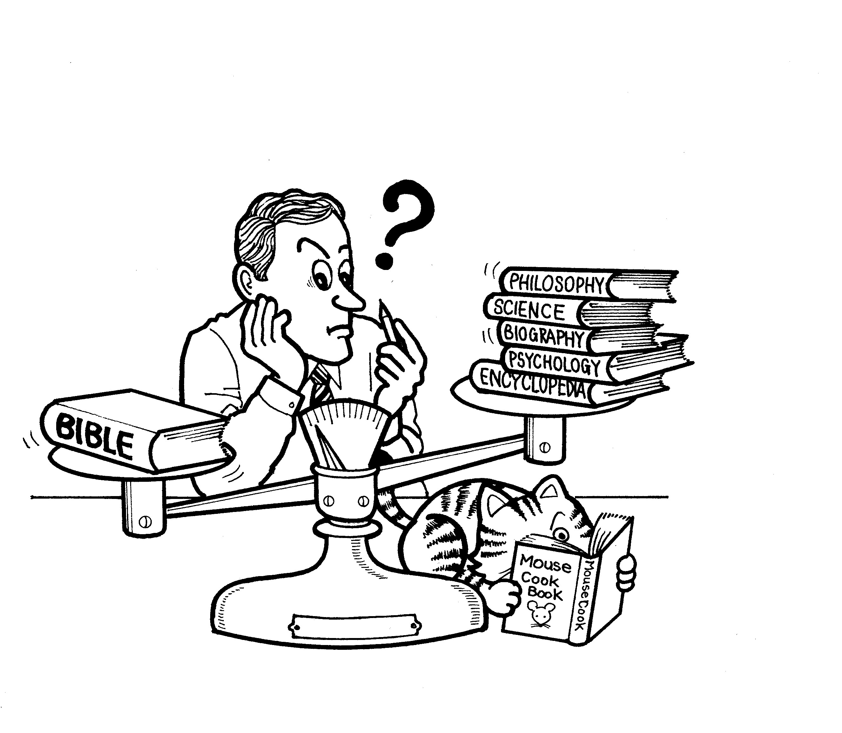

Introduction

If you wanted to learn something about math, you would probably read a math textbook. If you needed to do some scientific research, a book on science would be very helpful. A history book would give you information on historical events and if you needed to understand how to use a new computer you just bought, you would read the manual that came with it. However, if you wanted to understand life, or learn how to be a better person, where would you go for such information or help? How would you deal with common life problems such as fear, stress, discontentment, anger, jealousy or immorality that can adversely affect you and those around you? There are many ‘How To’ books for sale in the stores these days that offer all kinds of practical help and information on many subjects. But there is only one book that contains truth that is capable of changing your life both significantly and permanently. It is called the Bible.

The Bible is called the world’s bestseller because every year over 200 million copies of it are sold. The Bible has been translated into roughly 2,000 different languages and it is quoted from more than any other book ever written. What is so unique about this book? What do we know about it?

THE FACTS ABOUT THE BESTSELLER
- The Bible is divided into two sections known as the Old Testament and the New Testament. The Old Testament is comprised of 39 smaller books and the New Testament contains 27 books. Altogether, there are 66 books in the Bible.
- The word “Testament” means promise so the Bible is a record of God’s old and new promises to His people. The Old Testament is the foundation for the New Testament.
3. Much of the Bible is of a historical nature but it also has sections
containing laws, prophecy, poetry and even letters.
- The Bible was written over a span of 1,500 years from 1,400 BC to 100 AD.
- The men who wrote portions of the Bible had quite a variety in background. Some were kings, but included among the authors were also scholars, court officials, prophets, shepherds, fishermen, a doctor, priests, and a tax collector.
- Most of the Bible was written in Israel but significant portions were written elsewhere such as Italy, Egypt, Greece, Iraq, Iran and Turkey.
7. The oldest existing copies of the Bible date back to the 3rd century
B.C. and are known as the Dead Sea Scrolls.

THE NATURE OF THE BESTSELLER
1. Matthew 5:17-18 (NT 6) Jesus said all of the Bible was
important and would be fulfilled.
2. Unlike other books from the same era, the Bible does not contain
historical or scientific errors.
- Despite having been written by over 40 different authors over a length of 1,500 years, there are no inconsistencies in its message.
- The Bible portrays characters and events very honestly and often quite critically, as it is an accurate record of God’s truth.

THE AUTHOR OF THE BESTSELLER
1. The Bible is such a unique book that it had to have a unique
author. That author is God.
2. II Timothy 3:16 (NT 382) “All Scripture is inspired by God.”
3. II Peter 1:21 (NT 423) “…men moved by the Holy Spirit spoke
from God.”
- God used men with their individual personalities to accurately record His Word and preserve truth for all mankind.

THE PURPOSE OF THE BESTSELLER
According to the following passages, what are some of the purposes of the Bible?

1. John 5:39 (NT 167) It teaches us about eternal life.
2. Hebrews 4:12-13 (NT 393) It is like a sword exposing everything in our
lives
3. John 20:30-31 (NT 205) It helps us to believe that Jesus is the Christ
and that He alone can give us life.
4. II Timothy 3:15-17 (NT 382) It gives us wisdom and helps us do good
works.
5. Psalm 119:9-11; 105 (OT 942) It can help to guide and protect us.

Conclusion
The Bible is a record of God’s truth given to help men and women with their daily lives and to lead them to eternal life. Jesus said “Come to me, all who are weary and heavy-laden, and I will give you rest. Learn from me.” (Matthew 11:28)

If you are weary of trying to change your life and looking for answers, the Bible is a good place to begin your search. Like electronic products that are sold these days and are accompanied by thick instruction manuals, life is complicated. In fact life is much more complicated than any machine invented by man! Therefore, as the Creator of life, God has provided an instruction manual to help us in our journey. The Bible is that manual or unique “how to” book that can change your life and put you on the right path. Therefore, we will use the Bible as our textbook in our search for truth in the following lessons.
Beginning with God

The Truth about God – Part One

Lesson 2

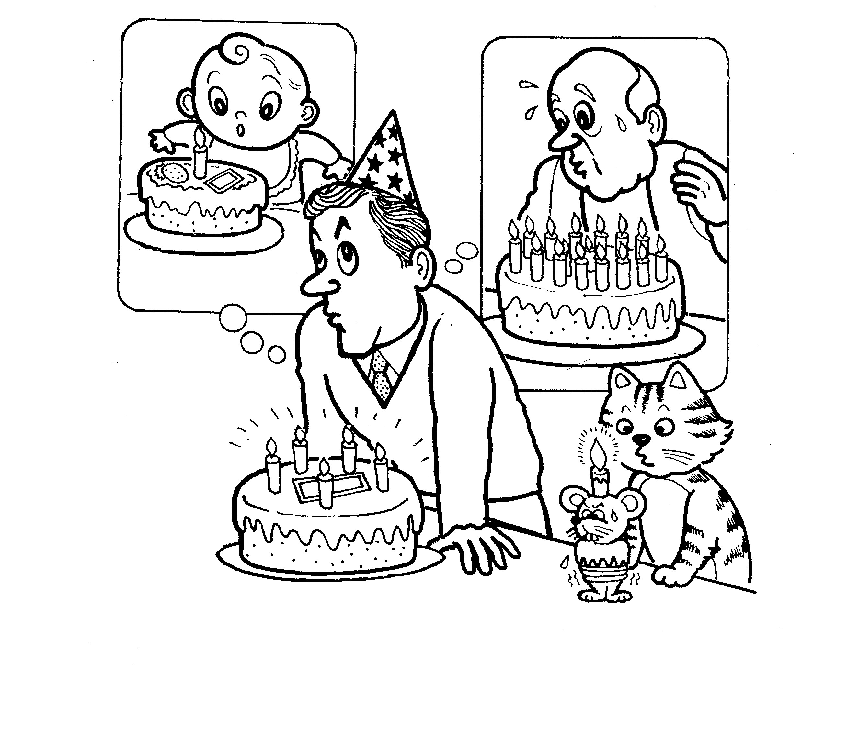
Introduction
“In the beginning, God created the heavens and the earth.” These are the first words written in the Bible in a section called “Genesis”. Genesis means literally “beginning” which is a very appropriate title as it records the beginnings of a number of things. We tend to think of everything as having a beginning. The beginning of life when a baby is born; the beginning of spring when the first flower blooms; the beginning of adulthood when someone turns 20 years old; .the beginning of the year is on January 1st. Everywhere we look we see events that mark the beginning of something but the Bible teaches that God is an exception to this rule. God had no beginning. He is eternal.

Who is this God? Does He really exist? If He does exist, what is He like and what does He expect from us? What is the truth about God that would be helpful for us to know?

IS THERE A GOD?

Romans 1:18-23 (NT 266)
1. If God exists, how would you describe Him? ________________________
2. God is described as being angry. What is He angry about? v.18
ungodliness, suppressed the truth
3. What has God made evident about Himself to all men? v.20
His invisible attributes, eternal power, divine nature

4. What two ways were these things made evident to men? vv.19-20
- Through Man’s heart
“that which is known about God is evident within them”
- Through the creation of the world
“…have been clearly seen, being understood through what has
been made”
5. How do you think man’s heart/conscience indicates there is a God?
Why do we have a concept of good and evil or a moral nature?
Why are certain acts considered to be ‘crimes’ in every culture?
Why are there so many religions in the world?
6. How do you think creation indicates there is a God? The complexities and
beauty of the natural world testify of God’s existence.
A design requires a Designer
7. Even though everyone knows something about God, what do they do?
vv.21-23 don’t honor Him; don’t give thanks; worship creation rather than
the Creator

Luke 15:1-7 (NT 133) Although many people ignore God, this passage presents another picture of God that is equally important to understand as we think about His existence.

- Why was Jesus criticized? He was spending time with bad people.
- What does the shepherd in the parable do? He searches for the lost sheep and rejoices when it is found.
- What does this tell us about God and His attitude toward us, even when we sin? He still loves us and wants to save us. That’s why Jesus spent time with everyone.

WHAT IS GOD LIKE?

There are two popular misconceptions about what God is like:
- Some people imagine God is like a kind grandfather. Some grandfathers can be very kind and generous to their grandchildren, and overlook the wrong things they do. In the same way, many people imagine a God who is all loving and punishes no one.
- Other people think God is like a policeman. Policemen are responsible for protecting the law and punishing criminals. In the same way, some people imagine a God who zealously punishes evil but is lacking in love and mercy.
Neither of these images of God is correct.

Acts 17:22-31 (NT 242) Like the people of Japan, the ancient Greeks were
very religious. Greece was a land full of temples dedicated to many gods.
Therefore, Paul tells them about the “unknown God”, or the true God.

1. What has God done?
- v.24 made the world
- v.25 gives to all life, breath, all things
- v.26 made every nation
- v.26 determined their appointed times and boundaries
2. What authority does God have?
- v.24 What is His title? Lord of Heaven and Earth
Why do you think this title is used for God?
____________________________________________________
- v.30 Who should obey Him? everyone, everywhere should repent

3. Where is God? What is God?
a. v.24 Where does God NOT dwell? temples
b. v.27 Where is God? not far from each of us
c. v.29 What is God not? image made by man from gold, silver or
stone

d. v.29 What is man called in relation to God? His offspring
How do you think this may be important? Man was made in God’s
image, not Him in ours.
4. What does God want from us?
a. v.25 Does God need anything from us? no! He gives everything
b. v.27 What does God want all men to do? seek Him
How do you think a person “seeks” God? _____________________
What kind of things do people usually seek? ____________________
c. v.30 What else should all men do? repent
What do you think it means to repent in relation to God? To have a
change of mind about what I do, say and think.
d. v.31 Why should all men repent? God will judge the world in
righteousness
e. v.31 Through whom will God judge the world? a Man He has
appointed and raised from the dead

Conclusion
Genesis records the beginnings of the earth and man, but Revelations, the final section of the Bible, prophesizes that both earth and man will have an ‘ending’. Like beginnings, endings are also an accepted pattern in our lives because of their inevitability. Farewell parties, graduations, retirements, end-of-year parties and more dramatically, funerals, all mark endings of one type or another in the natural flow of people’s lives. However, in contrast to man, God is without beginning or end as He is eternal. The Bible teaches that who God is, what He is like, and what He expects from us are crucial questions that have an important bearing on what type of ‘ending’ we will have. As we study more about God and man, we will learn what kind of ending and what kind of beginning God desires for each of us.
Eternal Treasure

The Truth about God – Part Two

Lesson 3

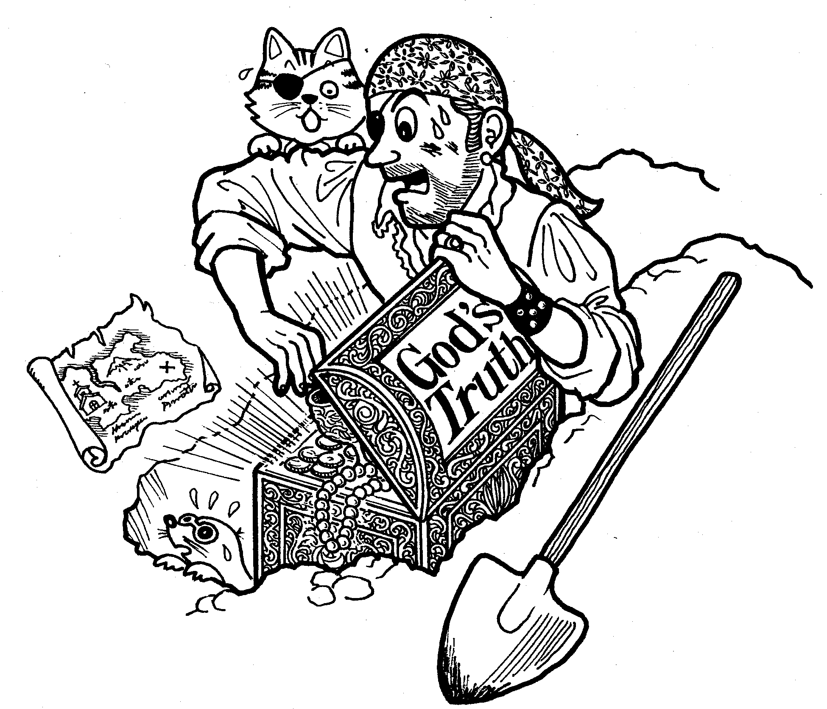
Introduction

Children often dream of finding buried or lost treasure worth a great fortune. Some may even go so far as to dig a few holes to look for it! Adults who buy lottery tickets are hoping to receive a treasure as well. But the Bible speaks of a different kind of treasure that is far more valuable. “The Lord is our God, the Lord is one! And you shall love the Lord your God with all your heart and with all your soul and with all your might.” (Deuteronomy 6:4-5) “The fear of the Lord is his treasure.” (Isaiah 33:6b) According to the Bible, knowing God and having a relationship with Him is described as being more valuable than any treasure we might find or desire in life. Therefore, we are encouraged, even commanded to seek Him, love Him and worship Him. But why should we seek God? Why is knowing God and having a relationship with Him so important?

GOD AND YOU
Psalm 139 (OT 960)
1. What does God know about me? vv.1-6
a. v.2 when I sit down and when I rise up
b. v.2. my thoughts from afar
c. v.3 my path and my lying down
d. v.3 all my ways
e. v.4 before there is a word on my tongue
2. Where is God in relation to me? vv.7-12
no matter where I go, God is with me
3. What has God done in relation to me? vv.13-16
created me; determined my “days”
4. How does the writer respond to this knowledge about God? vv.17-24
a. vv.17-18 he regards such knowledge as precious
b. vv.19-22 he has a zeal for goodness and hatred of evil
c. vv.23-24 he seeks a relationship with God
5. If such a God exists, how do you think we should respond to Him? ____________________________________________________________________________________________________________________________

GOD AND THE WORLD
Isaiah 40:18-31 (OT 1,090)
1. In verse 18, Isaiah asks, “to whom then will you liken God?” In an attempt
to capture the likeness of God, over the centuries, men have made idols
from various materials and worshiped them.
- Why do you think men make idols and serve them? vv.18-20 ______________________________________________________________________________________________________________
- How do you think God is different from an idol? ______________________________________________________
2. In contrast to an idol made by man, what is God’s power in relation to:
- The inhabitants of the earth? v.22 they are like grasshoppers in comparison
- The heavens? v.22 He stretches them out like a curtain or tent
- Rulers and judges? vv.23-24 He reduces them to nothing
- Stars? v.26 created, numbered, named and sustains them
3. In contrast to man, what is God’s character? vv.25, 27 holy, just
4. In contrast to man, what is God’s power? v.28
He is the Everlasting God
He is the Creator of the ends of the earth
He does not become weary or tired.
His understanding is inscrutable
5. God is described as the ultimate source of power and wisdom. What are
we encouraged to do to receive His help? v.31 wait on Him What do you
think this means?
___________________________________________________________

GOD AND LOVE
I Corinthians 13:1-8 (NT 307)
The Bible says “God is love” which means that love is an important part of who God is. It is part of His nature. However, as the word “love” is used quite loosely in today’s society, we need to see what the Bible says about love in order to fully understand this aspect of God’s character.

1. What is love more important than? vv.1-3 speaking in special languages,
being able to prophecy, knowing mysteries, having faith, sacrificial giving
2. What is love like? vv.4-7 patient, kind, rejoices in truth; bears, believes,
hopes, endures all things
3. What is love not like? vv.4-7 not jealous, doesn’t brag, not arrogant,
doesn’t act unbecomingly, doesn’t seek its own, not provoked, doesn’t take
into account a wrong suffered, doesn’t rejoice in unrighteousness, never
fails
4. How is this kind of love different from popular notions of love? _________
___________________________________________________________
5. How then is God different from man with regard to love? ______________
___________________________________________________________

GOD AND JUSTICE
Revelations 20:11-15 (NT 458)
God is love, but there is another aspect of God’s character that is equally important. God is also just or righteous. Just as a single coin has two sides that are quite different, these two characteristics of God, love and justice, are essential to God’s nature.

1. Where is God according to this description? v.11 sitting on a great white
throne
2. Why do you think God is described this way? ______________________
3. Who is standing before God waiting for judgment? v.12 the dead, both
great and small--everyone
4. On what basis are they judged? v.13 according to their deeds
5. What happens to those whose names are not written in the “book of life”?
they are thrown into the lake of fire
6. Although we may fear God’s justice, why do you think justice as a concept
is important? How is God’s justice important? _____________________
___________________________________________________________

Conclusion
Proverbs 1:7 “The fear of the Lord is the beginning of knowledge”. (OT 970)

Around 3,000 years ago, a king by the name of Solomon wrote about a ‘treasure’ that he considered more valuable than all the wealth of his vast kingdom. That treasure was knowledge of God, which in turn leads to knowledge of how to live wisely in a world created by God. Solomon further observed that the acquisition of such knowledge begins with fearing God, which means to respect God for Who He is and what He has done. “Fearing God” also implies an understanding that God expects something from each one of us. Therefore, we should seek God and obey Him. In doing so, we will receive a treasure of immeasurable value.
What is your treasure? What are you living for? How does it compare to the treasure of knowing the True God and having a relationship with Him? In the next few lessons, we will learn that man usually seeks different treasures other than knowing God and that this has both immediate and eternal consequences.
The Game of Life

The Truth about Man – Part One

Lesson 4


Introduction

Some families and many children like to play board games involving dice, which when thrown, determine how fast you advance in the game. Usually, you must collect certain items (often money!) or points, and overcome particular problems in order to win the game. Of course you have to know the rules of the game and keep them or the game would become meaningless.

Each day, in the real game of life, you throw the dice and move forward or backward according to the events and decisions of that day. Great successes, dismal failures, significant milestones and everyday events are crowded into the timeline of our lives that begins with birth and ends with a funeral. What are the rules for this game which all of us must play? Who makes the rules? What is the objective of the game?

We have already learned in Lessons 2 and 3 that God makes the rules. But what are the rules and what happens when you break them? What is the objective we should be aiming for as we move forward in the game of life?

THE BEGINNING OF THE GAME

Genesis

Creation of the Game Board Genesis 1:1-25 (OT 1)

1. According to Genesis 1, what did God create? Light, land, water, plants,
sun/moon/stars, living creatures
2. How did He create them? God spoke; out of nothing
3. What is said about each thing that God created? it was good

Creation of the Player(s) – Man Genesis 1:26-31 (OT 2)

1. What pattern did God use in making man? (v.27) in His own image
2. What authority and responsibilities are given to man? (v.28) multiply, fill
the earth, rule over the earth
3. According to this passage, how is man different from animals?
has authority over creation, everything made for man
4. What other ways do you think man is different from animals and similar to
God? he has a spirit, power, creativity, will, ability to communicate,
conscience, knowledge, emotions, faith, imagination, skill
5. What is said about man after God created him? (v.31) it was very good

Creation of the Rule(s) Genesis 2:15-17 (OT 3)

1. Where did God place man? (v.15) Garden of Eden
2. What freedom was given to man? (v.16) could eat from any tree
3. What was the one rule God gave to man? (v.17) not eat from tree of good
and evil
4. What do you think was the purpose of this rule? ____________________
___________________________________________________________
5. What would be the consequences of breaking this rule? (v.17) death

PROBLEMS IN THE GAME

The First Cheaters Genesis 3:1-7 (OT 3)

1. A new character or creature is introduced here. Who is he? What is he
like? (v.1) called a “serpent”; he is crafty, evil, lies, tempts, deceives
2. Why is the woman tempted to break God’s rule? (v.5) she wants to be like
God
3. How did the woman rationalize her disobedience? (v.6) She disregarded
God’s warning and decided for herself that the fruit: 1) was good for food,
2) was attractive and 3) would make her wise.
4. Why do you think people break rules? Why do they break God’s rules?
____________________________________________________________
5. What immediately happened after the man and woman disobeyed God?
(v.7) realized they were naked and made coverings.
6. What do you think is the significance of this? Their trust relationship with
God and each other is now broken so they feel vulnerable and in need of a
‘covering’.

The First Punishment Genesis 3:8-23 (OT 3)

1. What did the man and woman do when they sensed God’s presence?
Why? (v.8) hid themselves – ashamed of their nakedness
2. How do the man and woman explain their disobedience? (vv.12-13)
he blames the woman; she blames the serpent
3. How does God punish them all? (vv.14-19) The serpent will be forced to
crawl on his belly and will be bruised by the seed of the woman. The
woman will have pain in childbirth and be ruled over by her husband. The
man will have to work for his food and the ground will be cursed because
of him. He will return to dust.
4. How does God provide for the man and woman? What do you think this
symbolizes? (vv.21-23) removes them from the Garden; clothes them

THE GAME CONTINUES

The Rule-Maker and Rule-Breakers Genesis 6: 5-13 (OT 8)

1. What has happened since God’s first rule was broken? (v.5)
wickedness of man was great, thoughts evil; earth corrupted
2. How is man and the earth different from God’s original creation? evil
instead of good
3. How does God feel about this? What does He intend to do? (vv.6-7)
God is sorry He made man, grieved; plans to destroy the earth
4. Was anyone keeping God’s rules? Who was he? What was he like?
(vv.8-9) Noah
a righteous man who walked with God

Conclusion

Although the first man was created perfect by a perfect God, he and everyone else after him strayed from what God desired for them. God created man to do good so that he would enjoy all the blessings of life God had to offer. But God also created man in His own image, which meant that man had a free will when it came to choosing right from wrong. Unfortunately, man chose to do evil and separated himself from the God who created him and knew what was best for him. When man disobeyed God, he immediately recognized his nakedness or guilt before a holy God and sought to cover himself. However, only God can provide an adequate covering but it requires a sacrifice.

Unlike board games that are designed solely for the purpose of having fun, this game of life in which we all participate is very important and has significant consequences. As we move our pieces on the daily game board of life seeking to acquire happiness, love, joy, peace or goodness, it is important to know God’s rules and to obey them. However, as we study more about man, we will learn that even though man may know the rules, he needs help to win the game, because man is by nature a rule-breaker.
Weeds in God’s Garden

The Truth about Man – Part Two

Lesson 5

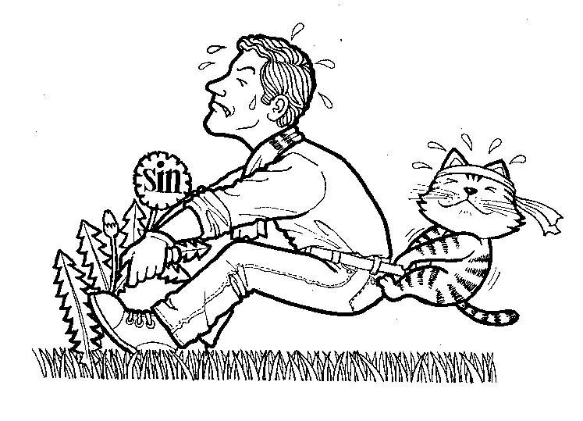 Introduction

A man was once very proud of his nice green lawn. He meticulously trimmed, watered, fertilized, and weeded it on a regular basis. Compared to the other yards in his neighborhood, he thought he had the perfect lawn. However, one day he decided to try a new type of fertilizer called “Weed and Feed” that was supposed to kill weeds in addition to fertilizing the grass. Two days later, he was shocked to see large brown dead patches scattered throughout his once beautiful lawn! Although the lawn had formerly appeared perfect to his untrained eye, there were actually many weeds in it, which the weed killer had revealed.

In Lesson 4, we learned that there have been ‘weeds’ in man’s life from the very beginning. Man is by nature a rule-breaker who generally ignores the God who made him and knows what is best for him. But how deep-rooted and widespread are these ‘weeds’ in our lives? What does the Word of God reveal about the depth and extent of sin in our lives?

WHAT IS A WEED?

The Ten Commandments
The Ten Commandments is the most famous list of rules ever recorded.
I You shall have no other gods before me.
II You shall not make for yourself an idol in the form of anything in heaven above or on the earth beneath or in the waters below. You shall not bow down to them or worship them.
III You shall not misuse the name of the Lord your God, for the Lord will not hold anyone guiltless who misuses his name.
IV Remember the Sabbath day by keeping it holy. Six days you shall labor and do all your work, but the seventh day is a Sabbath to the Lord your God. On it you shall not do any work.
V Honor your father and your mother, so that you may live long in the land the Lord your God is giving you.
VI You shall not murder.
VII You shall not commit adultery.
VIII You shall not steal.
IX You shall not give false testimony against your neighbor.
X You shall not covet your neighbor’s house. You shall not covet your neighbor’s wife, or his manservant or maidservant, his ox or donkey, or anything that belongs to your neighbor.

1. Which of the Ten Commandments are about sins against God? 1,2,3,4
2. Which of the Ten Commandments are about sins against man?
5,6,7,8,9,10
3. Which, if any of these commands do you think you have broken? How
often? (There is no need to record an answer here.)

Matthew 5:21-22; 27-28 (NT 6)
1. Jesus quotes two of the Ten Commandments here and further explains
them. What does He say about these sins? Murder = hatred, anger
Adultery = lust
2. What do you think Jesus saying about sin in general? ________________

Matthew 5:48 (NT 8)
1. Jesus explains God’s standard here for us. What is it? perfection
2. James 2:10 says “For whoever keeps the whole law and yet stumbles at
just one point is guilty of breaking all of it.” How is God’s standard different
from ours?__________________________________________________
THE EXTENT OF THE WEEDS
Romans 1:28-2:6 (NT 266)

1. A number of sins are listed in verses 29-31. Under which of the following
categories would you place them? (answers may differ widely as there is
no correct category)

ACTION SPEECH ATTITUDE
unrighteous deceit greed
wickedness gossip evil
strife slanderers full of envy
malice boastful murder
inventors of evil haters of God
disobedient to parents insolent
untrustworthy arrogant
without understanding
unloving
unmerciful
2. What do people who do such things deserve? (v.32) death
3. “You, therefore, have no excuse, you who pass judgment on someone
else, for at whatever point you judge the other, you are condemning
yourself, because you who pass judgment do the same things.”
(Romans 2:1)
4. Why do we have no excuse for our sins?
v.1 what we condemn in others we are guilty of ourselves
vv.2,5 God’s judgment is correct/fair
v.6 we are judged according to our deeds
5. Romans 3:10-11, 23 (NT 269) How many people deserve to be judged by
God because of their sins? everyone

HIDDEN WEEDS
Luke 18:9-14 (NT 139)
1. What kind of people did Jesus give this parable to? (v.9) He spoke to those
who thought they were righteous and looked down upon other people.
2. Who are the 2 main characters here? Pharisee, tax-collector
3. Why did they go to the temple? (v.10)) to pray
4. What was the difference in their prayers and hearts? (vv.11-13)
Pharisee: He was proud and boasted before God about what he had done.
Tax-collector: He was humble; recognized his sins, and asked for God’s
mercy.
5. What did Jesus say about these two men? (v.14) The tax-collector, who
recognized his sins before God, received mercy and was justified.
6. What do you think this parable teaches about sin and our need to recognize
it in our own lives? ____________________________________________

Conclusion
It took 2 billion dollars and several years to clean up the mess left behind by the Valdez, when it ran aground on the pristine coast of Alaska in 1989 spilling 232,000 barrels of oil. The environment and economy of the area were shattered. Sin is like a stain left on the world that pollutes relationships and needs to be cleaned up. Man can’t clean up this mess or pull his own weeds but the God who created him has provided someone for this seemingly impossible task. His name is Jesus and we will learn the truth about the essential role He plays in cleaning up man and forgiving his sins in the following lessons. So far, we have learned the bad news about man but from now on we will study the good news, or the gospel of Jesus Christ.

God’s Christmas Gift

The Truth about Jesus – Part One

Lesson 6

“I am the Truth”


Introduction
Every year on December 25th, millions of people around the world celebrate Jesus’ birth, which is otherwise known as Christmas. Although celebrations differ from country to country according to its customs, the exchanging of gifts seems to be a universal element of Christmas celebrations everywhere. Perhaps this is because the giving of a gift best symbolizes the essential meaning of Christmas when God gave the best gift of all, His son Jesus.

Gifts of course can differ in value and they are usually given to meet a particular need or desire of the recipient. We have already learned about man’s need to be “cleaned up” from sin in our previous lessons. Therefore, God has given to us a gift of inestimable value, at great cost to Himself, that provides exactly for this need. However, like a normal gift or present whose contents are hidden by wrapping paper, we need to remove the ‘wrapping’ around God’s present to us in order to fully understand and appreciate it. Who is Jesus? What did He do? What did He teach? These are some of the questions we must ask as we seek the truth about Jesus and learn about the importance of God’s gift to us.

THE DELIVERY OF THE PRESENT
Matthew 1:18-25 (NT 1)
1. Who was the real father of Jesus? (v.18) not Joseph, but the Holy
Spirit/God
2. What did Joseph plan to do when he heard Mary was pregnant? Why?
(v.19) He was a righteous man so he sought to put Mary away secretly,
without disgracing her
3. What stopped him? (v.20) An angel explained everything to him in a
dream
4. What did the angel tell him? (vv.20-21) He should name the child Jesus.
The child will save people from their sins
5. Who besides the angel had said these things before? What did he say?
(vv.22-23) a prophet. A virgin will give birth to a child. His name will be
Immanuel
6. What is the meaning of the name “Immanuel”? (v.23) God is with us
7. What else do you know about Jesus’ birth? born in a stable, shepherds
came to worship Him, a star guided the wise men, etc.
8. If you were God, how would you ‘deliver’ such an important present? ____

A DESCRIPTION OF THE PRESENT

John 1:1-18 (NT 157)
This passage, in contrast to the one we just studied in Matthew, uses quite a different approach in describing Jesus. Rather than using His name, Jesus is referred to as the “Word” since the author wants to communicate some very unique things about Jesus.

1. What is said about the “Word” in the following passages?
v.1 In the beginning was the Word
The Word was with God
The Word was God
v.3 All things came into being by Him
v.4 In Him was life, and the life was the light of men
v.14 The Word became flesh and dwelt among us
2. A man named John is introduced here, what was his role? (vv.7-8) to bear
witness of the Light/Jesus, that all might believe
3. What was the general response to Jesus? (vv.10-11) many did not know
Jesus or receive Him
4. What was promised to those who did receive Jesus? (v.12) the right to
become children of God
5. What does one have to do in order to receive this promise? (v.12) believe
in His name
6. Why do you think only this condition is given?_______________________

Philippians 2:3-11 (NT 352)
1. What kind of attitude did Jesus have that we are encouraged to copy in
verse five? (vv.3-4) Jesus was humble, placed other people’s needs
ahead of His own.
2. Verses 6-7 say that although Jesus “existed in the form of God …He
emptied Himself, taking the form of a bond-servant, and was made in the
likeness of men.”
3. Because Jesus was both God and man, what was He able to do? (v.8)
obey God and die on the cross
4. Because of this what does God do? (v.9) God exalts Jesus
5. What should we do? (vv.10-11) Worship Jesus and confess Him as Lord

A RECIPIENT OF THE PRESENT
John 4:3-30; 39-42 (NT 163)
This is a story of a woman from Samaria who met Jesus and received God’s present. Samaritans lived near Israel and although they were distantly related to the Jews, their religious practices were quite different. As a result, Jews and Samaritans generally disliked and avoided each other.

1. What does Jesus do that indicates He does not hold the typical Jewish
prejudice against Samaritans? (vv.4,7) Jesus deliberately traveled
through Samaria. He asked the woman for a drink.
2. How does the woman respond to Jesus’ request? (v.9) She is surprised
Jesus spoke to her
3. What does Jesus offer her that only He can give? (v.10) living water
4. She doesn’t understand what Jesus is offering so how does He explain it?
(vv.13-14) If she drinks the water Jesus offers, she will never thirst again.
It will bring eternal life
5. How does she respond to Jesus’ offer? (v.15) She asks to receive the
living water. She believes even though she doesn’t fully understand
everything yet.
6. Jesus then reveals He knows what kind of woman she is. What else does
He observe about her? (vv.16-18) She had 5 husbands which revealed
her immoral lifestyle.
7. Why do you think He brings this up? Jesus wanted her to recognize her
need for forgiveness
8. What is her response to this? (vv.19-20) She thinks Jesus is a
prophet and talks to Him about worship
9. Jesus then explains some things about the true worship of God.
(vv.21-24)
What is not important? location
What is important? Must worship God in spirit and in truth
10. What do you think this means? Men tend to emphasize external things in
worship but Jesus said it involves the heart of man, done in a way that is
acceptable to God.
11. What else does Jesus say about Himself? (vv.25-26) He is the Messiah-
Christ
12. What did others say about Jesus? (v.42) He is the Savior of the world
13. If you had been at the well and overheard this conversation, what would
you think about Jesus and how would you have responded? __________
___________________________________________________________

Conclusion
Sometimes we may not immediately perceive the full value of a present we have received. Stories abound of priceless antiques or collector’s items that were sold as junk but brought their new owners incredible riches when they realized the true value of their purchase. The value of God’s supreme gift to us, His son Jesus, becomes clearer as we more closely examine His life and teaching, which we will continue in Lessons 7 - 8.

Mystery Clues

The Truth about Jesus – Part Two

Lesson 7

“I am the Truth”

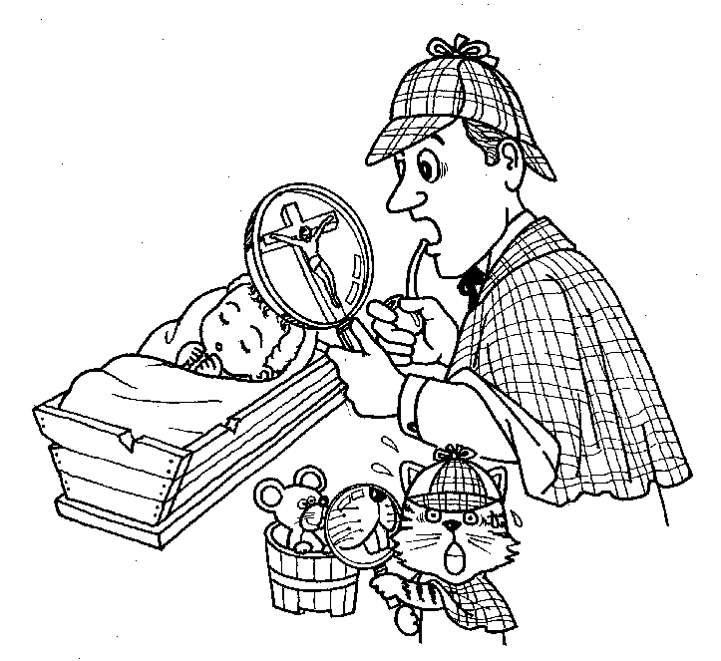 Introduction
Every mystery novel or movie begins with creating a question or situation that requires an answer. The question before us as we continue our study is a rather unusual one. That is, “If God became a man, what would He be like?” What kind of things would He do? What would He say? How would He live? If you were a detective and your assigned case was to determine the identity of Jesus, these are some of the questions you might ask in your investigative efforts. As you searched for clues, you would want to examine the testimony of the witnesses, or people who had an encounter with Jesus. You would be expected to investigate what Jesus taught and what He did in your search for the truth about Him.

The Bible says of Jesus: “For in Christ all the fullness of the Deity lives in bodily form.” (Col. 2:9) What does this mean? If Jesus is God, what should we expect to observe about Him in the Bible as we continue our investigation? Let’s look at the clues and see where the evidence leads us.

CLUE #1 JESUS PROVIDES

John 6:1-15; 25-35 (NT 168)
As we begin our investigation, it may help you to realize that millions of other people have gone before you seeking to discover the truth about Jesus. This passage tells us about a large group of people (over 5,000) who had seen Jesus’ miracles and heard His teaching and therefore wanted to know more about Him.

1. In verses 1-15, Jesus recognizes the need of the people and helps them.
What is their need? food
How does Jesus provide for them? He feeds them
2. As a result, what does the crowd think about Jesus? (v.14) They think He
is the promised Prophet.
As a result, what do they try to do? (v.15) They try to make Jesus their
king.
3. How does Jesus respond to their efforts? (v.15) He leaves them to be by
Himself.
4. In verses 25-35, Jesus recognizes another need of the people that they
themselves are unaware of. What is it? (v.27) Eternal life
How can they obtain it? (v.29) by belief in Jesus
5. Jesus said to them (v.35) “I am the bread of life; he who comes to Me shall
not hunger, and he who believes in Me shall never thirst.” What do you
think this means? ____________________________________________
______________________________________________________________

CLUE #2 JESUS HEALS
John 9:1-7; 24-41(NT 178)
Instead of a crowd, Jesus ministers to the need of an individual in this situation. As a result, the Jewish religious leaders (Pharisees) continued to oppose Jesus.

1. What mistaken assumption did Jesus’ disciples have regarding the blind
man? (v.2) They assumed he was blind because he or his parents had
sinned.
2. How did Jesus correct them? (v.3) Jesus said his blindness was not a
result of sin but part of God’s plan.

3. Before Jesus heals him, what remarkable thing did He say about Himself?
(v.5) “While I am in the world, I am the light of the world.” Why do you
think Jesus said this? ________________________________________
4. Although the blind man was healed of his blindness he still needed to be
healed from his sins. How does he receive this healing? (vv.34-38) He
believes in Jesus and then worships Him
5. Who else was ‘blind’ according to this passage? (vv.39-41) The Pharisees,
or anyone who doesn’t recognize his own sin.
6. In Matthew 9:12-13 Jesus said, “It is not the healthy who need a doctor,
but the sick. For I have not come to call the righteous, but sinners.”
According to this passage, who did Jesus come to heal? sinners

CLUE #3 JESUS TEACHES
Matthew 7:24-29 (NT 11)
This passage is the conclusion of a very famous sermon given by Jesus that is popularly referred to as the “Sermon on the Mount”.
1. If someone listens to and obeys Jesus’ teaching what is he like? (vv.24-25)
He would be like a person who built his house on solid rock.
2. In this parable, what do you think the house, 2 foundations, and storm
represent?
House = a person’s life
2 Foundations = what a person trusts
Storm = trials in life or God’s judgment
3. Why do you think one man was considered wise and the other foolish?
___________________________________________________________
4. How did the crowd react to Jesus’ sermon? (v.28) They were amazed at
Jesus’ teaching.
5. How was Jesus’ teaching different from the scribes? v. 29 He taught with
authority.

CLUE #4 JESUS FORGIVES
Matthew 9:1-8 (NT 13)
1. When a paralytic is brought to Jesus, what does Jesus initially do for him?
(v.2) Jesus forgave the man’s sins
2. How do the scribes, or religious leaders react? (v.3) accuse Jesus of
blasphemy
3. Jesus then heals the paralytic. Why? (vv.5-6) to prove He had the power
to forgive.
4. How did the other witnesses of this event react? (v.8) Filled with awe;
glorified God.

CLUE #5 JESUS SERVES
John 13:1-17 (NT 189)
Even though Jesus knows He is about to die, in His last meeting with His disciples Jesus demonstrates His remarkable love for them (v.1).
1. What does Jesus do for His disciples? ( vv.4-5) He washes their feet.
2. How does Peter respond? (vv.6-8) He tries to stop Jesus from washing his
feet.
3. What does Jesus tell Peter? (v.8) Peter needed to be washed by Jesus.
What do you think this means? Peter needed to have his sins forgiven.
4. What else does Jesus want His disciples to learn from His example?
(vv.13-14) They need to serve one another.

CLUE #6 JESUS SAVES
John 11:7-45 (NT 183)
Lazarus, the brother of Mary and Martha, had died in Jesus absence and had already been in the tomb four days when Jesus arrived.

1. How did Martha express her faith in Jesus? (vv.21-22) She said Jesus
could have healed Lazarus because God would give Jesus anything He
asked for.
2. What was Jesus reply to her in verses 25-26? “I am the resurrection and
the life; he who believes in Me shall live even if he dies, and everyone who
lives and believes in Me shall never die. Do you believe this?”
3. How does Martha answer Jesus’ question? (v.27) She believes Jesus is
the Christ.
4. How did Mary show her faith? (v.32) She said Jesus could have healed
Lazarus.
5. What did Jesus do to prove He was the resurrection and the life?
(vv.40-44) He raised Lazarus.
6. How did the others who witnessed this miracle respond? (v.45) They
believed Jesus.

7. Jesus raised a man who had been dead four days. What significance do
you think this has for others who believe in Him? ____________________
______________________________________________________________

Conclusion
Mark 10:45 “For even the Son of Man (Jesus) did not come to be served, but to serve, and to give His life a ransom for many.” (NT 81)

“If God became a man, what would He be like?” was the question we started with as we launched our investigation in this chapter. We have looked at only a small portion of the evidence in today’s study. What have we learned after examining the clues recorded in God’s Word? The evidence of the Bible tells us that even though Jesus was God, He came not in the form of a king, but in the form of a servant. At the same time, He said and did things unlike any man before or since then. As a result, many people believed in Jesus and their lives were changed forever. However, as we continue our investigation, we will learn in the next lesson that Jesus’ death was just as important as His life in making this change possible.

History and the Cross

The Truth about Jesus – Part Three

Lesson 8
“I am the Truth”

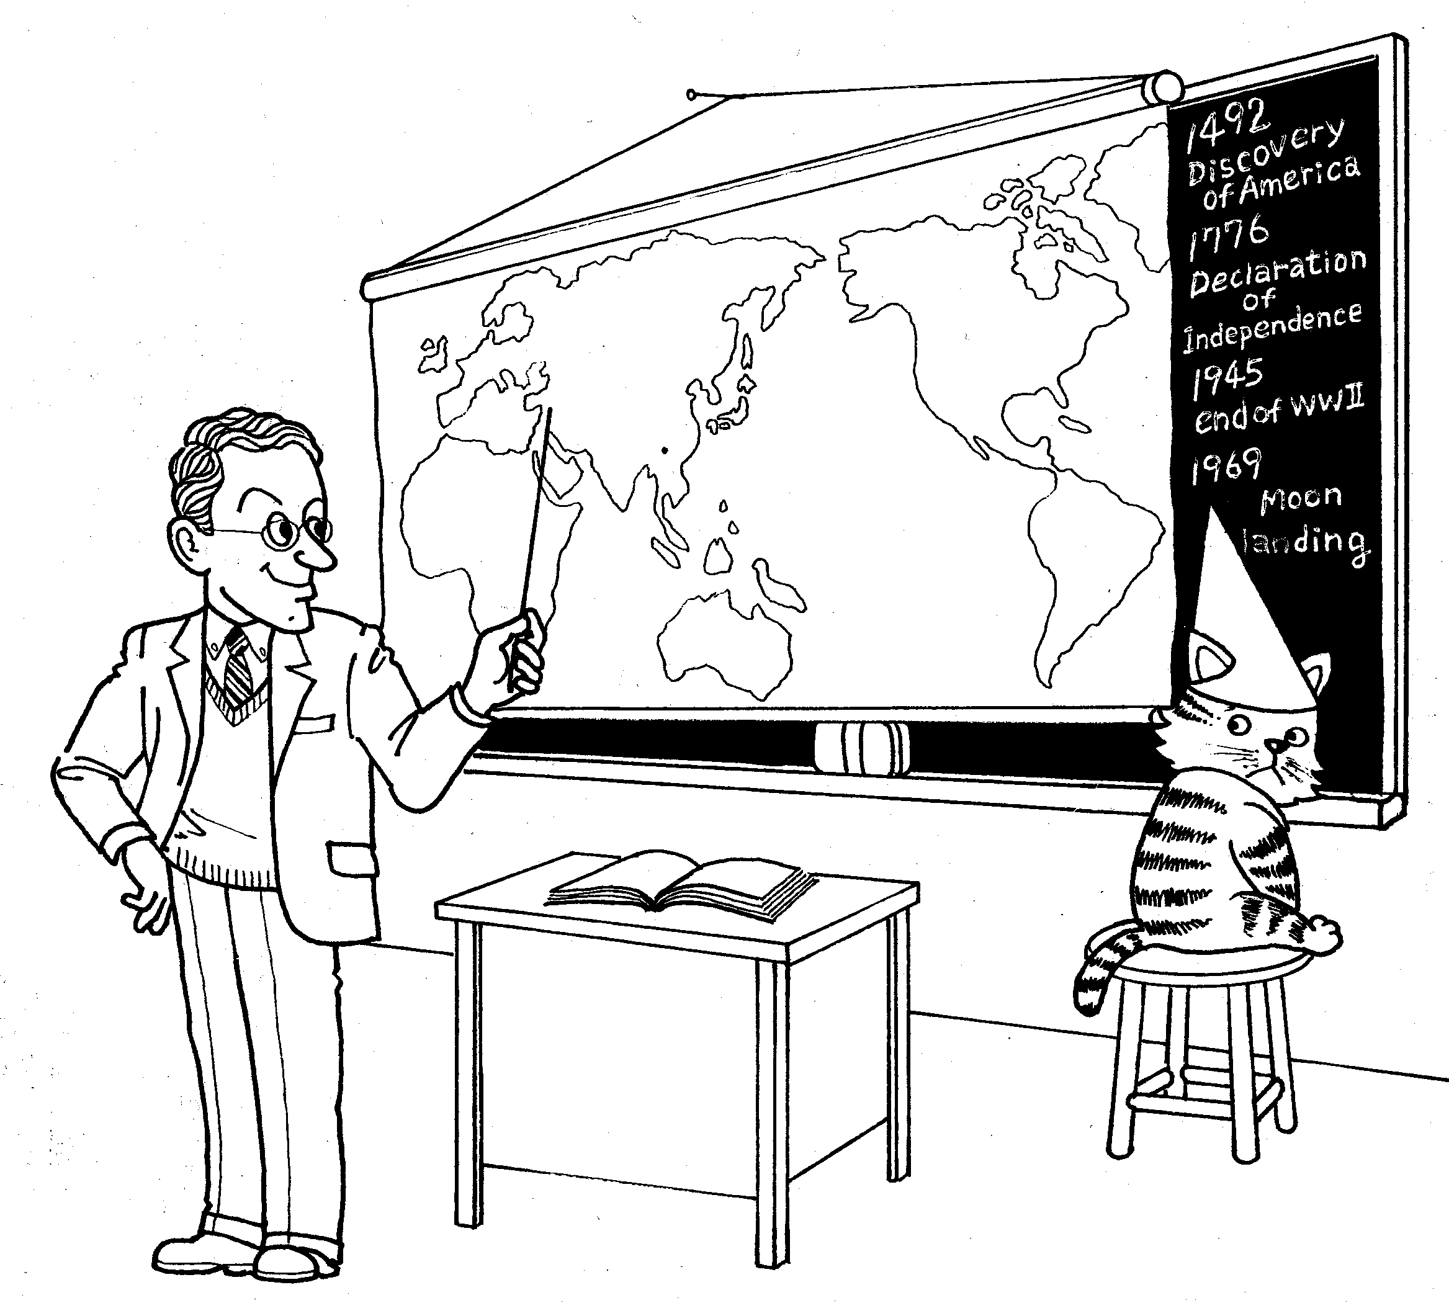
Introduction
Although most of us have forgotten much of what we learned in history class, there are certain historical events that were so important and significant in their impact, they remain clearly etched in our memories. For example, in 1492 the famous explorer, Christopher Columbus, discovered a new continent. A new nation and democracy was born on that same continent in 1776 with the signing of the Declaration of Independence. 1945 marked the end of a terrible world war and the advent of an even more terrible weapon. Many witnessed history in the making in 1969 on TV when a man walked on the moon for the first time.

All these events and many others seem worthy of our attention, but somehow the execution of a single man, in a remote corner of the world in 33 AD has overshadowed the many events in history that it both preceded and followed. At that time, Jesus’ brief life was abruptly cut short when He was crucified as a common criminal by the orders of a Roman magistrate. Yet, the means and symbol of His death, a cross, is known throughout the world and His followers currently number in the millions. What was the significance of that event, not just in historical terms but more importantly, in spiritual terms? Why was the death of one man so important?

THE PREDICTION OF THE CROSS

Isaiah 53:1-12 (OT 1,114)
The Book of Isaiah was written about 600 years before Jesus was born, yet it and many other OT passages make remarkable predictions about the birth, death and resurrection of a savior. Isaiah 53 gives a description of someone’s future death and its implications.
1. What happens to this man?
despised and forsaken of men (v.3)
acquainted with grief (v.3)
smitten of God and afflicted (v.4)
pierced through for our transgressions (v.5)
crushed for our iniquities (v.5)
by His scourging we are healed (v.5)
the Lord has caused the iniquity of us all to fall on Him (v.6)
His grave was assigned with wicked men (v.9)
He was with a rich man in His death (v.9)
will be allotted a portion with the great (v.12)
2. What does He do?
He did not open His mouth (v.7)
will justify the many (v.11)
will bear their iniquities (v.11)
bore the sin of many (v.12)
3. What terms are used to describe Him?
man of sorrows (v.3)
like a lamb led to slaughter (v.7)
the Righteous One, My Servant (v.11)
4. Who does this seem to be describing? Why? ______________________
___________________________________________________________

Mark 8:31-37 (NT 75)
1. Jesus made several predictions about Himself here. What were they?
(v.31) He would be rejected by religious leaders, suffer, be executed, and
rise again
2. How did Peter, one of Jesus’ disciples, respond to this? (v.32) He
rebuked Jesus
3. What was Jesus’ answer to Peter? (v.33) Peter needed to focus on God’s
purposes, not his own personal desires.
4. What challenge did Jesus then present to the others who were present?
(v.34) They need to take up their cross and follow Jesus.
What do you think this means? They need to obey/believe Jesus
5. Why should they or we accept that challenge? (vv.35-37) Nothing is
more important than our souls yet, no matter what we have or do, we
cannot save ourselves

THE EVENTS OF THE CROSS
Luke 23:1-56 (NT 151)
1. What similarities can you find between the prophecies in Isaiah and the
events of Jesus’ death as recorded by Luke? despised by men, falsely
accused, didn’t defend Himself, mocked, innocent, scourged, like a lamb
led to be slaughtered, died with criminals, buried in rich man’s tomb, bore
the sin of many
2. What did the following people say about Jesus or do to Him?
Pilate vv.4,14, 22 declared Jesus’ innocence
Herod vv.14-15 found Jesus innocent of accusations
Crowd vv. 27, 48 mourned Jesus’ suffering and death
Leaders vv.2,21,35 falsely accused Jesus, mocked Him, asked
for His death
Soldiers vv.11, 34, 36 mocked Jesus, gambled for His garments

Centurion v.47 praised God, declared Jesus’ innocence
Criminals vv.39-41 one mocked Jesus; one recognized Jesus’
innocence
3. On the day Jesus was crucified, two criminals benefited from Jesus’ death.
How did Jesus’ death save them?
Barabbas vv.17-19,25 He was saved physically by Jesus taking his
place
Thief on the cross vv.40-43 He was saved spiritually by Jesus taking
his place
4. Romans 5:8 says “But God demonstrates His own love toward us, in that
while we were yet sinners, Christ died for us.” (NT 271)
If Jesus died to save obvious sinners like criminals, what do you think His
death can accomplish for sinners like us? __________________________
____________________________________________________________

THE MIRACLE AFTER THE CROSS
John 20:1-31 (NT 203)
1. Even though Jesus had predicted not only His death, but also His
resurrection several times, His followers were apparently surprised when it
actually happened. Why do you think they responded that way?
___________________________________________________________
2. One particular disciple, named Thomas, said he would not believe Jesus’
resurrection until he had what evidence? (v.25) He wanted to see and
touch the scars from Jesus’ crucifixion
3. How did Jesus answer Thomas’ doubts? (v.27) Jesus let Thomas touch
and see His scars.
4. How does Thomas then respond to Jesus? (v.28) He calls Jesus his Lord
and God
5. Who does Jesus say will be blessed?(v.29) Those who believe without
seeing
6. According to verses 30-31, Jesus performed many signs or miracles and
the greatest one was His resurrection from the dead. What was the
purpose of these signs? To believe Jesus is the Christ, the Son of God so
that you will have life in His name.
7. If you were among the witnesses to these events, what would you think?
___________________________________________________________
___________________________________________________________

Conclusion

Isaiah 53:6 (OT 1,114) “All of us like sheep have gone astray, each of us has turned to his own way; but the Lord has caused the iniquity of us all to fall on Him.”

John 10:11 (NT 181) “I (Jesus) am the good shepherd; the good shepherd lays down His life for the sheep.”

“Why was the death of one man so important?” was the question we asked ourselves as we began this lesson. The Bible pictures all men as being like sheep that are lost. We have wandered away from God and pursued the wrong things in life. Therefore, God sent His Son, as the Good Shepherd, not just to guide us or merely to provide a good example, but to die for us so that we might have eternal life and abundant life. The birth, life and death of many famous men and women have been duly recorded in history. But only the voluntary death of one man on a cross and His subsequent resurrection from the dead deserves to stand above all other historical events. We will look at the present significance of this historical event to you in the following lesson.

God’s Path

The Truth about Salvation

Lesson 9

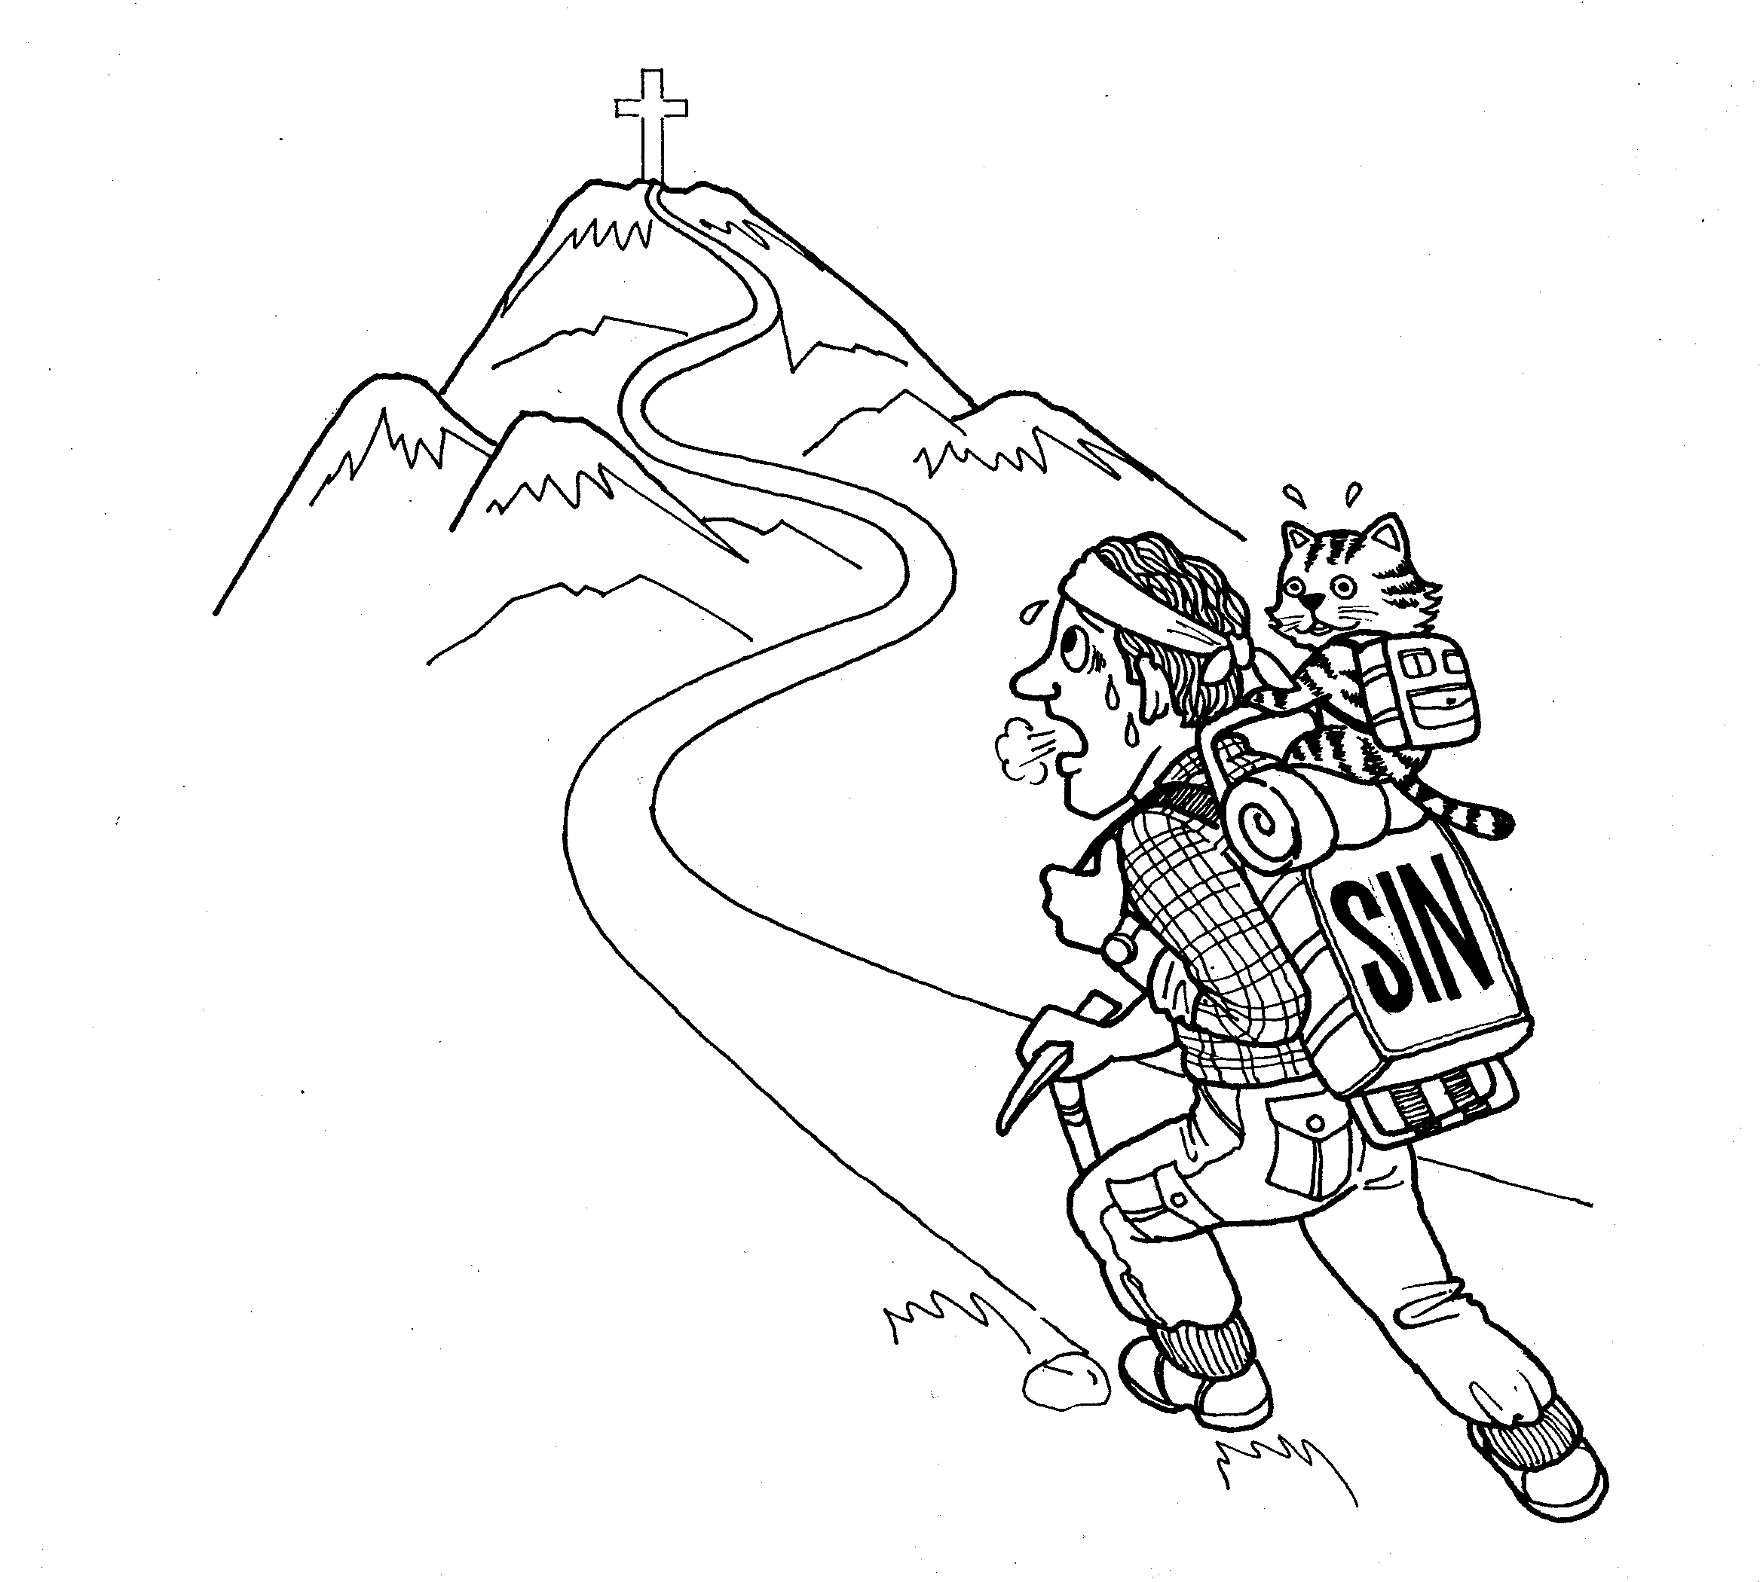
Introduction

Some people think that all religions are like climbing Mt. Fuji. As there are many paths to the summit of Mt. Fuji, they think there are many paths to God. In other words, it isn’t important which path or religion you chose as long as you are sincere and try your best to stay on the particular path you have chosen.

The Bible teaches very clearly that there is indeed a path to God, but there is only one and it takes a very unusual, unexpected route. It goes by way of a cross, a device commonly used for executing criminals. However, in this case it is used by God to demonstrate the depth of His love for all men in providing them a Savior. Jesus said, “I am the way, and the truth and the life; no one comes to the Father (God), but through Me.” (John 14:6) God has provided a path through the death of His Son because of our own inability to provide one or stay on one ourselves. The path provided by God is not based upon the depth of our sincerity or even the many good things we might do in our lifetime. Rather, this path is based upon what God did for us at the cross through the death of His Son.

To more fully understand this path, we will look at several key passages that once again highlight the necessity of the path and God’s graciousness in providing it.

THE PROVISION OF THE PATH
Genesis 22:1-14 (OT 30)
Abraham was a man of great faith who walked with God. As a result, God promised to bless him with many descendents and use him to be a blessing to the whole world. Abraham waited 25 years for the fulfillment of this promise before God finally gave him a son by the name of Isaac. Then God asks Abraham to do something very unusual with his only son that in turn teaches some important truths about God and His provision of His only Son, Jesus.
1. What did God tell Abraham to do? (v.2) travel to Moriah to sacrifice his
son Isaac
2. How does Abraham respond? (v.3) He obeys God and begins the journey
with Isaac
3. Isaac realizes something is missing for a sacrifice. What is it? (v.7) a
lamb
4. How does Abraham answer Isaac’s question? (v.8) God will provide the
lamb
5. Why do you think a lamb or sacrifice was so important? Man needs
something suitable to offer to a Holy God as a substitute for his sins
6. What does God dramatically provide for Abraham? (v.13) a ram caught in a bush
7. In thanksgiving, what did Abraham name that place? (v.14) The Lord Will Provide
8. In John 1:29 (NT 158), Jesus is called “the Lamb of God who takes away the sin of the world.”
- What similarities and contrasts do you see between the events of Genesis 22 and Jesus being called the “Lamb of God”? ______________________________________________________
- What need does the “Lord Provide” for through Jesus? __________
______________________________________________________

THE NECESSITY OF THE PATH

Romans 5:6-11 (NT 271)
1. How are we described in verse 6? Why do you think we are described
this way? helpless--because of our sins we cannot make our own path to
God
2. What did Jesus do for us? (v.6) He died for us
3. Why is this so unusual? (vv.6-8) We wouldn’t normally sacrifice ourselves
even for a good person, but Jesus died for us even though we are sinners
4. What does this tell us about God? (v.8) He loves us very much
5. God loves us, but how does He feel about our sins? (v.9) angry
6. How else are we described in relation to God? (v.10) Why do you think
we are called this? God’s enemies--we disobey/ignore God
7. Despite this, what does God do for us through the death of His Son?
(vv.10-11) God reconciles us to Himself

John 3:16-21 (NT 161)

1. John 3:16 is perhaps the most famous verse in the Bible. “For God so
loved the world, that He gave His only begotten Son, that whoever
believes in Him should not perish, but have eternal life.”
2. Who does God love? (v.16) the world; everyone
3. What does God provide for them? (v.16) Eternal life through His Son
4. Why is this necessary? (vv.16,18) they were going to perish, be judged for
their sins
5. What can we do to receive this provision? believe in Jesus
6. However, many people don’t receive this provision or want to take the path
God has so graciously provided. Why is that? (vv.19-20) They love the
darkness; their deeds are evil

AN ILLUSTRATION OF THE PATH

Luke 15:11-32 (NT 134)
Jesus often told stories in order to make spiritual truths easily understood. Through the story of the prodigal son, Jesus communicates some essential truths about the heart of God and the heart of man.
1. What unusual thing did the younger of two sons ask his father? (v.12) he
asked for his share of the inheritance while his father was still alive
2. What did the younger son do with what he received? (v.13) he
squandered it with loose living
3. What happened to him? (vv.14-16) he became desperately hungry as no
one helped him
4. What does he decide to do? (vv.17-19) he decides to return to his father
to ask for forgiveness
5. How does the father respond to his repentant son? (vv.20-24) he
welcomed his son back and forgave him
6. How does the older son react to his younger brother’s return and his
father’s subsequent welcome for him? (vv.25-30) he becomes angry and
resentful that his father welcomed his younger brother back
7. How does the older son compare himself to his younger brother?
(vv.29-30) unlike his younger brother, he says he has always worked for
his father, obeyed him and has not wasted his father’s money.
8. How does the father explain his actions? (vv.31-32) He said they must
rejoice because his son had been lost but was now found.
9. If the father in this story represents God, what does it say about Him? He
loves us and is eager to forgive us
10. If the two sons represent two different types of people what is the
difference? those who realize they are ‘lost’/sinners and those who don’t
realize they are ‘lost’
11. What should a ‘lost’ person do? he should recognize his sin, seek
forgiveness, repent and depend on God’s mercy

Conclusion

If every man, woman and child in the world were lined up on the coast of California and ordered to swim to Japan, how many do you think would make it? Obviously none! The task is impossible. Some would certainly swim further than others but everyone would eventually drown trying to make it on their own. But if someone came by in a boat and took them to Japan the result would be quite different.

The Bible clearly teaches that getting to heaven, or pleasing God through our own efforts is like trying to swim to Japan from California. It just cannot be done. Therefore, God has provided a boat or a path to get you there through the death of His Son, Jesus. If you realize you are drowning in your sins, the Bible exhorts you to cry out for help. God is waiting to save you because He loves you.

“For the word of the cross is to those who are perishing foolishness, but to us who are being saved it is the power of God.” I Corinthians 1:18 (NT 291)

The Tightrope of Life

The Truth and You

Lesson 10

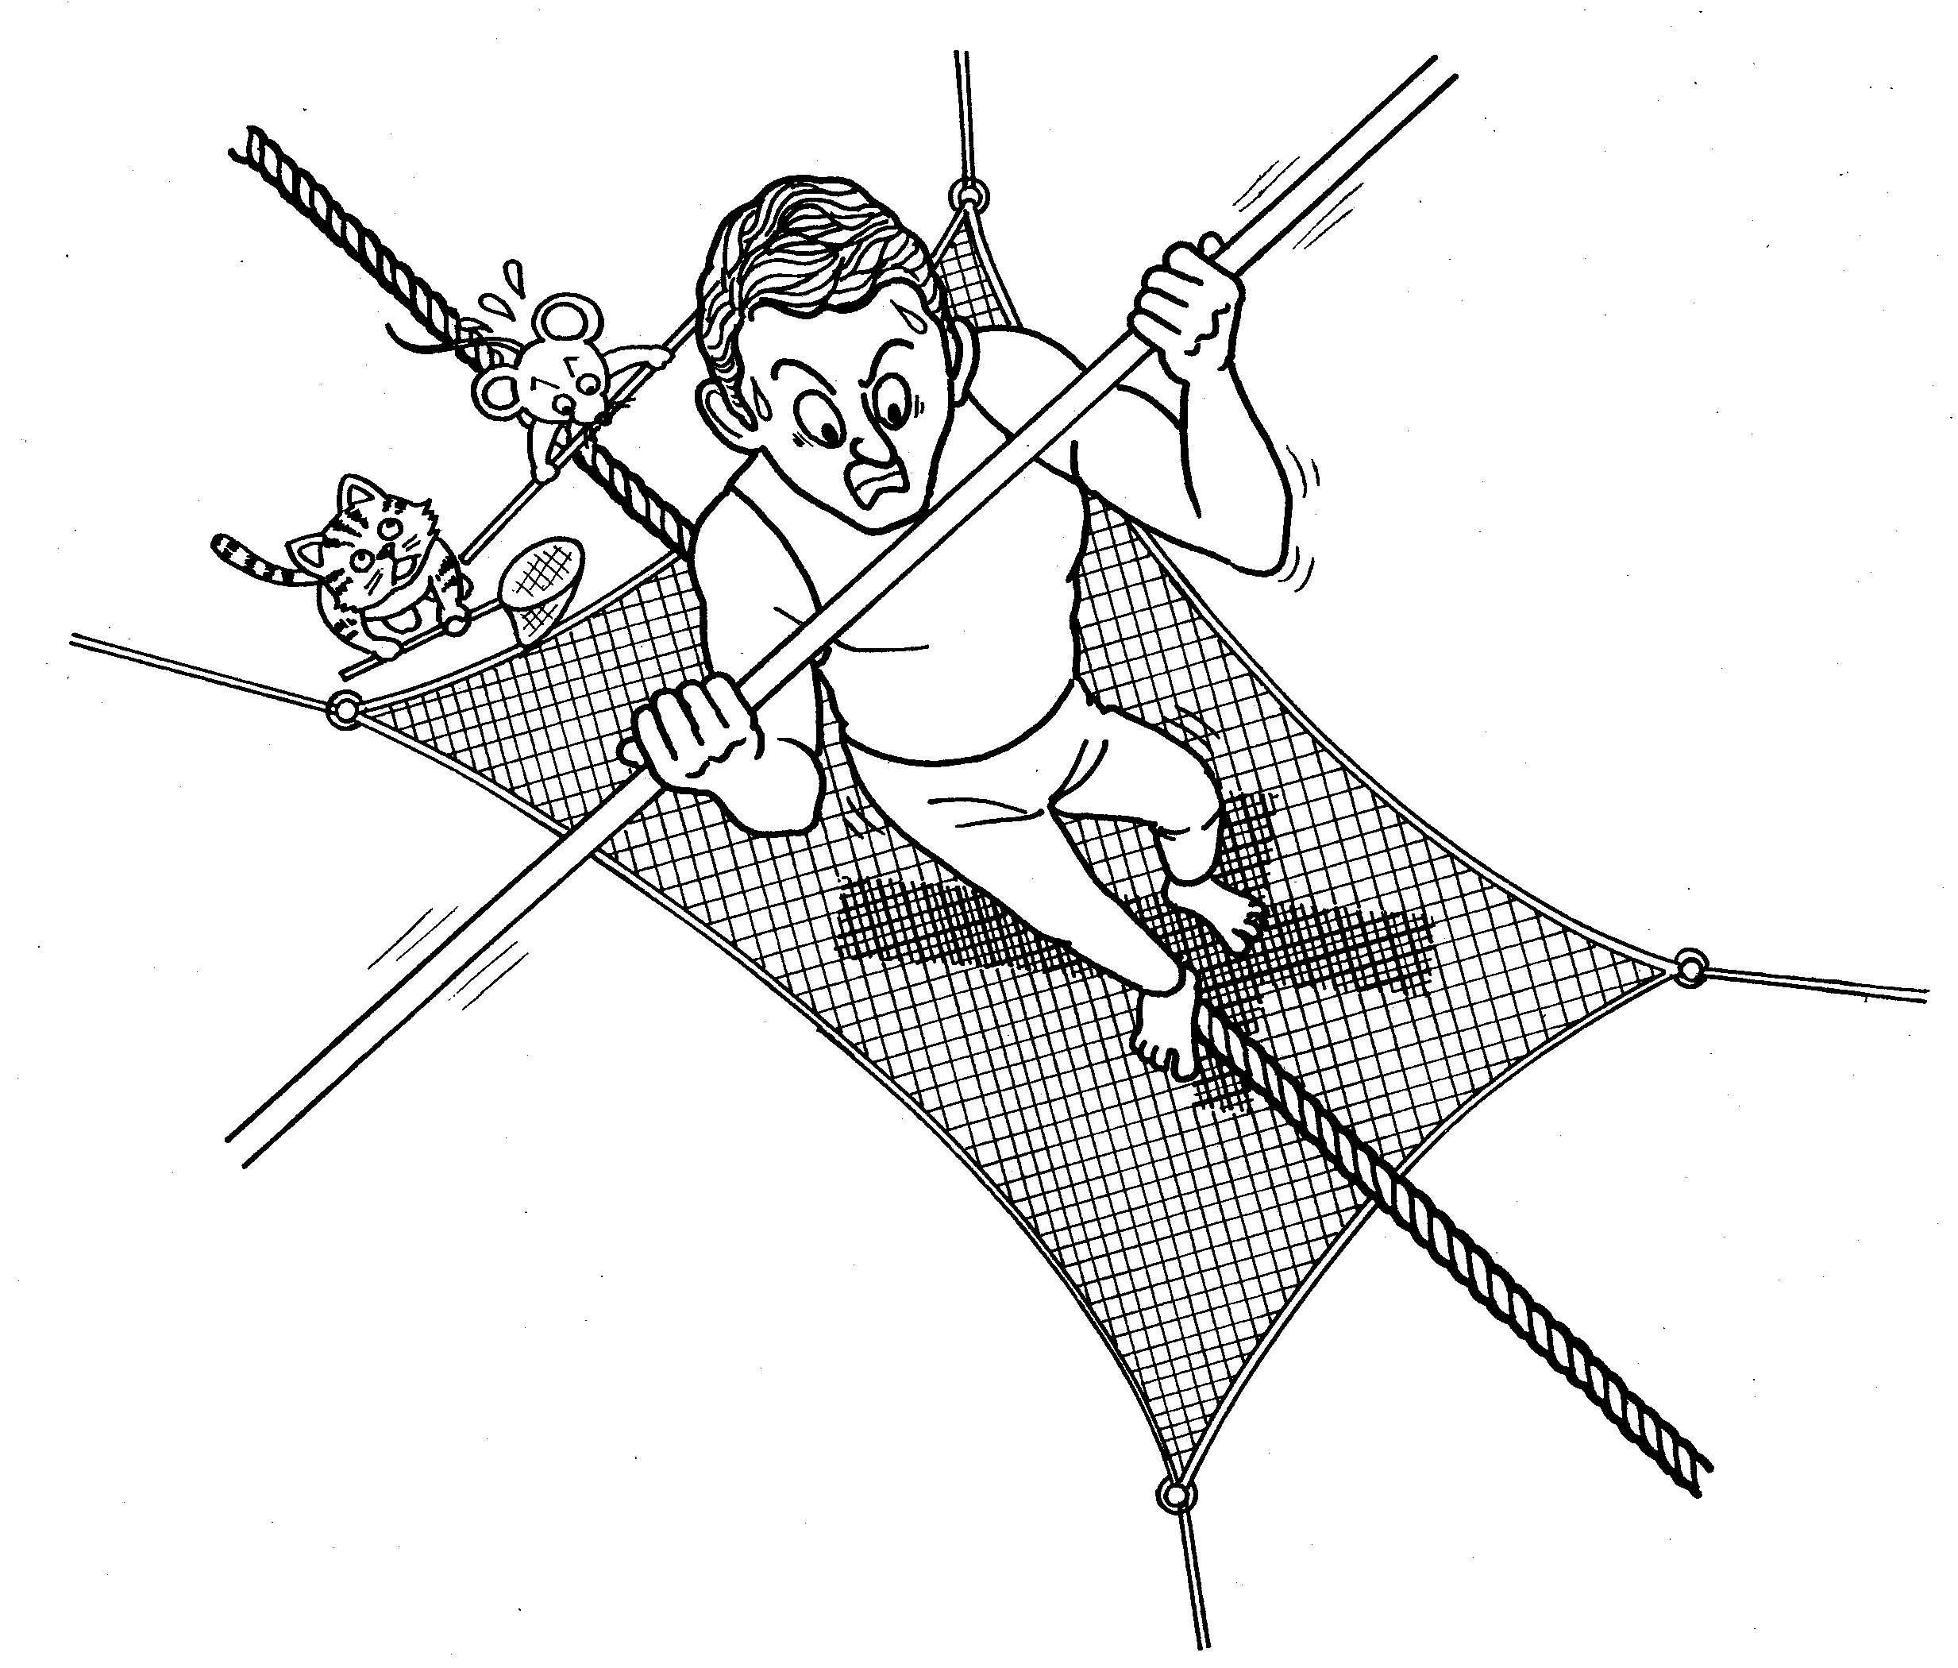
Introduction

Karl Wallenda was a world famous tightrope walker who along with his family had performed death-defying feats hundreds of times on the high wire. However, at the age of 73, while performing in front of a large crowd in Puerto Rico, Wallenda lost his balance and plummeted to his death several hundred feet below. Despite the fact that Wallenda had done far more dangerous feats many times before without a mistake, that one slip killed him.

As we have learned already, the Bible teaches that no matter how good we may think we are or try to be, all of us have slipped off the perfect standard of a holy God. The result of that slip is not just physical death, but spiritual death. (“It is appointed for men to die once and after this comes judgment.” Hebrews 9:27) However, the Bible also teaches that God loves us so much that He has provided a safety net for us to fall into through the death of His perfect Son, the Lord Jesus Christ.

One man, who realized he couldn’t stay on God’s perfect tightrope, once asked the important question: “What must I do to be saved?” and the answer given to him was: “Believe in the Lord Jesus, and you shall be saved.” (Acts 16:30-31) This question, asked by a jailer in Philippi hundreds of years ago, has been repeated millions of times over the centuries by many others like him, who have also believed in God’s safety net, Jesus Christ. These people are called Christians. We have learned so far in our study many truths and that truth is of utmost importance. But truth alone is of no value to us unless we believe it and act upon it. Where do you stand in relation to God’s truth?

FALSE TIGHTROPES

Luke 12:13-34 (NT 127)
1. Whenever Jesus gave a parable, it was usually in response to a problem
or question. What problem prompted Jesus to give this particular
parable? (vv.13-15) Two brothers were arguing over their inheritance
because of their greediness.
2. What warning does Jesus give them in verse 15? beware of greed
because life is more important than possessions
3. What does the parable of the Rich Fool teach about pursuing wealth as our
main goal in life? (vv.16-21) We may place our trust in wealth but it can’t
save us or give us true happiness. “The man who lays up treasure for
himself is not rich toward God.” (v.21)
4. Jesus doesn’t teach that having possessions or being rich is wrong.
Instead, He tells us not to worry about these things. (vv.22, 25-26, 29)
5. What two natural examples does Jesus give to illustrate God’s care for us
and why we don’t need to worry? (vv.24-28) ravens and lilies How do
they illustrate the benefits of trusting God? As God takes care of the
natural world which He created, He will take care of us too. Therefore, we
should trust God.
6. What are we to seek instead of wealth or possessions? (vv.29-31) God’s
kingdom
7. This passage teaches that riches or possessions can distract us from
seeking God and trusting Him. What do you think are some other things
that can keep us from seeking God? busyness, fear, pursuit of
wealth/success, people, pride, false religions

Ephesians 2:8-10 (NT 342)
1. Verse 8 teaches some very important elements about the safety net God
has provided for our sins. “For by grace you have been saved through
faith; and that not of yourselves, it is the gift of God.”
2. In the Bible, “grace” means to receive something you don’t deserve. In
this passage, salvation is also described as a “gift”. From what you have
studied so far, how do you think salvation is a gift, or act of God’s grace?
____________________________________________________________
____________________________________________________________
3. According to this same verse, what can we do to receive this gift of
salvation? have faith
4. According to verse 9, what can we not do to receive this gift? work for it
5. Can you think of some examples of how people try to work for salvation?
give to charities/religions, do volunteer work, join a religion, try to be a
good person, etc.
6. Even though we can’t earn our salvation through our own efforts, why did
God create us? (v.10) to do good works__________________________

GOD’S SAFETY NET
I Peter 2:21-25 (NT 417)

1. How was Jesus uniquely different from us? (v.22) He committed no sin
2. What did this enable Jesus to do on our behalf? (v.24) bear our sins on
the cross so that we might be healed/saved
3. What are we compared to? (v.25) lost sheep What do you think this
means? We have separated ourselves from God and His purposes for us
4. In light of this, God has provided Jesus as the Shepherd and Guardian of
our souls. (v.25) What do these terms tell us about what Jesus can do for
us? ________________________________________________________
___________________________________________________________

(You may have noted several similarities between this passage and Isaiah 53 which we studied previously in Lesson 8)

HOW TO LAND IN GOD’S SAFETY NET

Isaiah 55:1-13 (OT 1116)

1. According to verse one, if you are thirsty God offers you water. If you have
no money you are still allowed to buy food. What do you think this means?
___________________________________________________________
___________________________________________________________
2. Give some examples of things we usually spend our money on or make a
focal point of our lives. entertainment, house, pets, family, car, travel,
education, etc.
These things may be good or necessary, but can they satisfy us spiritually
and eternally? No!
3. Therefore, what are we encouraged to do?
v.2 listen carefully to Me (God)
v.2 eat what is good
v.3 listen, that you might live
v.6 seek the Lord while He may be found
v.6 call upon Him while He is near
4. Why should we do these things?
v.7 He will abundantly pardon
v.9 God’s ways are higher than our ways
v.9 God’s thoughts are higher than our thoughts
v.11God’s word accomplishes whatever He desires

John 7:37-38 (NT 174)
1. Jesus said “If any man is thirsty, let him come to Me and drink. He who
believes in Me as the Scripture said, ‘From his innermost being shall flow
rivers of living water.”
2. Jesus quotes from the Prophet Isaiah (55:1) and makes an incredible offer
to us. What is that offer? He will give us living water if we are thirsty.
3. What do you think this “living water’ is? ___________________________
4. What do we have to do to receive it? Acknowledge our thirst, come to
Jesus and believe in Him

Conclusion
The famous French acrobat, Charles Blondin, crossed the Niagara Falls in 1860 on a 335 meter tightrope suspended 50 meters above the raging water. Then to the amazement of the crowd, he crossed it again pushing a wheelbarrow in front of him. When his manager asked the crowd if they believed Blondin could cross back to the other side with a man in the wheelbarrow, they all enthusiastically expressed their confidence in the Great Blondin. However, when the manager invited anyone in the crowd to get into the wheelbarrow, no one took him up on his offer. The manager himself then got in the wheelbarrow and Blondin took him safely across. Everyone had believed that Blondin could perform the feat, but no one acted on their faith.

Perhaps you have come to recognize your own spiritual thirst by now and want to receive the water of life that God offers freely to you. However, it is not enough just to know the truth, you must act on it. You have to get into the wheelbarrow and place all your trust in Jesus despite any fears or uncertainties you might have. Only He can take you safely to the other side. Only He can forgive your sins and give you a meaningful life that lasts for all eternity. The Bible makes it very clear that you cannot get to the other side on your own. You need a Savior. You need Jesus. He is the truth that can change your life forever.

Jesus says: “Behold, I stand at the door and knock; if anyone hears My voice and opens the door, I will come in to him, and will dine with him, and he with Me.” (Revelation 3:20) Opening the door to Jesus means: 1) that you recognize and repent of your sin before the Holy God who created you and 2) that you receive Jesus as your Savior by believing in Him. Have you done this already? If not, are you ready to get into the wheelbarrow and trust Jesus?

How Can I be Saved?

If you are hesitating to trust Jesus and get into the wheelbarrow , perhaps it would be helpful at this point to review what we have studied over these past ten lessons. You may be thinking, “Why do I even need to get into the wheelbarrow?!” Or, “Why do I need to be saved?”

One of the first truths we studied is that God created everything, including you. This God loves you and desires to have a relationship with you for all eternity. However, the Bible also tells us that we have sinned against God by repeatedly breaking His laws. Therefore, we face God’s judgment and deserve punishment, as we are all lawbreakers. That was the “bad news” that we learned about in lessons 2-5.

“The wages of sin is death”
(Romans 6:23a)

However, the “good news” (gospel) is that even though we are disobedient, God has provided another way for us to have an eternal and meaningful relationship with Him. That way came not through anything we can do, but through the death of God’s Son, Jesus, on a cross. God loved us so much, that He gave His only Son to receive the punishment we all deserve.

“But the gift of God is eternal life in Christ Jesus our Lord.”
(Romans 6:23b)

To receive this gift of eternal life and forgiveness of sins, there is only one thing you can do. You must believe in Jesus. Your search for truth, which began with God, ends at the cross and is validated by an empty tomb. It is not a matter of what you have done or can do, but rather what God has already done for you because He loves you. The strength of your faith or the intensity of your feelings are unimportant. God only asks that you believe in His Son, whom He has given to the whole world as their Savior. Won’t you get into the wheelbarrow today? Won’t you trust Jesus as your Savior? Like the father of the prodigal son, (Luke 15), God is waiting for you with open arms.

You can pray to God something similar to this:

“Heavenly Father, I believe that you exist and that
you love me. I also realize that I have sinned
against You. Please forgive me and cleanse me. I
believe that Jesus died for my sins on the cross and
rose from the dead. I receive Him now as my
Savior. Please take control of my life and guide me.
Amen”

If you have prayed this prayer from your heart, tell another Christian or pastor. They will be glad to teach you additional truths from God’s Word to help you grow spiritually

Appendix

LESSON 1 (Begin with self introductions if your students don’t know each other. You may want to ask each student what they expect from this study series.)
What kind of “How To” books have you read or would like to read? What kind of “How To” book would you like to write?
Have the student open his Bible to the table of contents as you explain the varied nature of the books of the Bible.
This is an important discovery because it validates many of the prophetic portions of the Old Testament.
Jesus emphasized that even the smallest parts of the Bible were important like the dotting of an “i” or crossing of a “t”. This points to the Bible’s uniqueness compared to other books.
The Bible is not a science or history textbook, but it is significant to note that it contains no historical or scientific errors characteristic of the time in which it was written. The Bible, unlike some other religious books, has needed no modern editing to correct such mistakes. In fact, the Bible has become a reliable tool for modern archaeologists and historians as they attempt to piece together an accurate picture of the past.
The literal meaning here is that Scripture is “God breathed”, emphasizing that the words of the Bible are God’s words to us.
If you received a letter from someone you loved very much, you would carefully read every word and pay close attention to what that person said. In the same way, the Bible is like God’s love letter to us.

LESSON 2

When you were a child, who or what did you want to become when you grew up? Why?

What is the difference between God’s anger and the kind of anger we often condemn in man? (God’s is righteous; man’s is selfish.)

Matter and motion are important elements in the laws of physics. But matter requires a Maker and motion requires an Initiator. That Maker and Initiator is God. Just as a song requires a songwriter and a painting requires a painter, the world by its very complexity
requires a God.
The ancient Greeks worshiped many gods such as Zeus (the chief god), Poseidon (god of the sea), Hades (god of the underworld), Apollo (god of the sun), Aphrodite (goddess of love) and many others. They believed these gods had certain powers, responsibilities and limitations as well. In many ways, the Greek gods were very much like normal people except they were immortal and more powerful. The Bible however describes the True God as being very different from the gods of Greek mythology.
Why do you think men build temples?

Man often wants to ‘create’ a god or gods in his own image that he can manipulate or control as he pleases. Many religions reflect this desire of man. The Bible teaches the opposite. (Gen.1:26-27)

John 5:24-29 (NT 166)

LESSON 3

If you could buy anything you wanted, what would it be? Why?

Because the Psalmist has a correct understanding of God (1-16), it affects his attitude toward evil and evil doers. His love for God and the things of God leads him to passionately reject evil.

Although almost everyone seeks love, we also value and depend upon justice. Who wants to live in a world where people are free to break rules and laws without fear of punishment?

For many, it is difficult to understand how God can be loving and exercise judgment at the same time. A good parent does the same thing. A parent who truly loves his child will not only show them affection or provide for the child’s needs. Love requires that the parent also maintains the rules of their family (justice) and punishes or corrects the child when needed.

Matthew 13:44-46 (NT 24)

LESSON 4

What rule(s) did you not like when you were a child? Why?
What games did you like to play as a child?
As the Bible is not a scientific textbook (cf. Lesson 1), it does not give specific details as to how God created everything but instead describes what God has created. However, there is a pattern.

Day 1 | Light/Darkness | Sun, Moon, Stars | Day 4
Day 2 | Sky/Sea | Birds, Fish | Day 5
Day 3 | Sea/Land/Plants | Insects, Animals, Man | Day 6

The modern theory of evolution is often promoted as the only valid scientific explanation for the origin of the world but it too requires faith. One scientist has observed that it is more likely for a tornado to go through a junk yard and construct a 747 jumbo jet than it is for man to evolve entirely by chance.

Genesis 2:7 (OT 2)

Parents make and enforce rules for their children even when they are quite small. Sometimes the purpose of a rule is to protect the child while at other times it may be to teach a social behavior or ethical conduct. As God only gave one rule here, it must have had a very important purpose. Without a rule or choice, how could man exercise his free will?

The judgment of death was both of a physical and spiritual nature. Immortality was denied to man and eternal punishment became a real possibility.

The desire to be like God has universal appeal because everyone wants to be in control of his own life and do whatever he pleases. We want the power to make our own rules and decide for ourselves what is best for us. Like Eve, we are tempted to reject God’s right to rule over our lives.

Skeptics who question the existence of God like to ask the question,“How can a good God allow evil?” How can you answer this question based on the content of Genesis 1-3?

From the very beginning of time, it is made clear that only God can adequately cover the “nakedness” or guilt of man. This covering required the taking of another life, in this case an animal’s, but in the future God would provide a perfect sacrifice for man’s sins. That would be His own son, the Lord Jesus Christ. As a punishment and as an act of mercy, God removed Adam and Eve from the garden. If they had eaten from the tree of life, which was also in the Garden, they would have remained forever in a state of condemnation.

John 15:5 (NT 193)

LESSON 5

What kind of flower, fruit and vegetable would you
like to have in your garden? Why?

Why do you think man’s standard of what is defined
as sin is so much lower than God’s?

Suppose you made an omelet using 6 eggs but one
of the eggs was rotten. Would you still want to eat the omelet? Of course not! Just as one rotten egg can ruin an omelet, one sin separates us from a holy God and invites punishment.

Some people have a very simplistic view of God and His standard of justice. They imagine a God who ‘weighs’ each person’s good deeds and bad deeds on His scales of justice. According to this thinking, if a person has done more bad than good, he deserves to be punished. However, the Bible teaches that if there are any bad deeds on our scales, we have broken God’s holy standard and deserve to be punished.

Galatians 5:19-24 (NT 339)

People tend to minimize their own sins and say they don’t deserve to be punished. Such an attitude shows an incomplete understanding of God and His standard of justice. For example, policemen don’t just arrest murderers, but give tickets to people who break traffic laws as well. Therefore, if I get stopped for speeding, I will have to pay a fine. I may feel bad about what I’ve done and promise to never speed again, but it doesn’t erase the fact that I have broken the law and deserve to be punished. Judges as well are not allowed to arbitrarily enforce some laws and ignore others. By His very nature, God must enforce the rules He has made for man.

Mark 7:18-23 (NT 72)

The Pharisees were religious leaders who were admired because of their zeal for keeping God’s law. Tax-collectors were generally despised because of their dishonesty and greed.

The main point of this parable is that although both men were different in their external behavior, they had one point in common; they were both sinners. However, only one (the tax-collector) recognized his sinfulness and need for mercy and forgiveness. In contrast, the Pharisee’s pride blinded him to his own sin.

The great French physicist and philosopher, Blaise Pascal said, “There is a God-shaped vacuum in the heart of every man which cannot be filled by any created thing, but only by God the Creator Himself, made known through Jesus Christ.”

John 8:3-11 (NT 174)
I John 1:8-10 (NT 426)

LESSON 6

What was your favorite present you received as a
child? Why?

The name “Jesus” means literally “God saves”.

The Bible clearly teaches that Jesus was unique not just by what He did but by who He was. Jesus was a man but He was also God. The importance of this dual nature of Jesus will become evident as we learn more about Jesus.
If you wanted to communicate with your pet goldfish there would only be one way to do it. You would have to become a goldfish! In the same way, God revealed Himself to man and communicated with man by becoming a man Himself.
John 10:30-33 (NT 182)

What are the benefits or privileges of being someone’s child? What do you think would be the benefits or privileges of becoming God’s child?

If Jesus was not God, He would not have been able to live a sinless life. If Jesus was not man, He would not have been able to die on the cross as a substitute for our sins.
Most Jews would take a circuitous route when traveling from Judea to Galilee in order to avoid meeting a Samaritan.

The title “Christ” is taken from the Greek word for “Messiah,” which is a Hebrew word that means literally the “Anointed One”. People, particularly kings, were often anointed with oil when they were appointed for a special service. The Jews and Samaritans both were waiting for God’s promised Messiah or Christ, who would deliver them from their sins.

LESSON 7

Do you like mystery novels or books? Can you think of one you particularly enjoyed?

Many people wanted a Messiah who would be a powerful leader and free them from the tyranny of the Roman Empire. Instead, Jesus offers a much different and far more crucial form of power ~ eternal life, abundant life and the forgiveness of sins.

Unlike the Jewish religious leaders who could only quote God’s Word and give their interpretations, Jesus spoke as if God’s Word was His own, because He was God. Therefore, Jesus spoke with an authority the other religious leaders didn’t possess, even though they had received much more training.

Note what Jesus says about Himself in Matthew 28:18 (NT 57)

If a guest came to your house and started to wash your dishes, vacuum your floors and wash your clothes, you would feel very uncomfortable, even if these things needed to be done! Therefore Peter tried to stop Jesus from washing his feet. But through Jesus’ example, Peter recognized: 1) his selfishness in that he had been unwilling to serve the other disciples and 2) his need to have his own sins forgiven

Matthew 8:23-27 (NT 13)

Jesus said many incredible things about Himself and
many incredible things were written about Him. We can explain these things by classifying Jesus in one of the four following ways: He was a Legend, He was a Liar, He was a Lunatic, or He is Lord. The Bible and millions of other testify that Jesus is Lord.

If you were a detective, what conclusions would you reach about Jesus after examining the clues we studied today?

LESSON 8

If you could take a time machine and go back anywhere in history, where would you go? Why?

Jesus is not exhorting people to emulate Him by literally dying on a cross as He did. Rather, Jesus is dramatically pointing out the need to die to self in order to follow Him. It is not possible for a person to continue to rely on his own good works for salvation while at the same time trusting God to save them. To follow or believe in Jesus means I must surrender all that I have previously trusted. Like the literal bearing of a cross, this is a difficult thing to do.

I Timothy 2:3-6 (NT 373)

A man by the name of Shamile was the leader of some Russian revolutionaries trying to overthrow the Tsar of Russia. Life was very difficult for them as they were always trying to avoid the Tsar’s soldiers and there was never enough food. One day, it was reported to Shamile that someone in their group was secretly stealing food from the supply tent so he announced that if the thief was caught, he would be publicly whipped. A few nights later, the thief was caught but the thief turned out to be Shamile’s own mother! Shamile now had a bigger problem. If he had his elderly mother whipped, she would probably die. Yet, if he did not punish her, he would be breaking his own rules and undermining his authority. Therefore, he decided upon an unusual solution. Instead of having his mother whipped, Shamile took off his shirt and received his mother’s punishment in her place. In this way, he showed love for his mother and satisfied the need for justice.

In the same way, God showed His love for us and protected justice by offering His Son Jesus to die on the cross. Jesus took our place and received the punishment for our sins that we deserved.

LESSON 9

Where was one of your favorite places to take a
walk? Is there particular place where you would like to walk or is there any mountain you would like to climb?

From the beginning of creation after man sinned, God required man to offer a suitable sacrifice whenever he sinned. In such a dramatic fashion, God sought to impress upon man the seriousness of sin. God would forgive sin, but it could only be granted through the death of a suitable substitute, such as an unblemished lamb. Through this ritual, man came to understand the holiness of God and the price of forgiveness. God would eventually provide the perfect sacrifice through the death of His Son on the cross. After that, sacrifices were unnecessary.

How can God love us and be angry with us at the same time? Perhaps if you think of the relationship between a parent and a child you can answer this.

I Peter 3:18 (NT 419)

You may have several keys on your key ring because the locks to your car, house, office, etc. are different and require different keys. In the same way, there is a ‘key’ to heaven and forgiveness of sins, but there is only one key. That ‘key’ is Jesus.

Can you think of some reasons why a person would not want to take the path God has provided? Are these good reasons?

Would you consider yourself as being a ‘lost’ person spiritually? Why or why not? Is there anything you need to do?

LESSON 10

What was the most dangerous thing that ever
happened to you?

I Peter 5:7 (NT 421)

When a person seeks God’s kingdom, he is seeking the things that God values and accepts His authority over his life. Since God is our Creator, He knows what is best for us and we should submit to Him. Only then can we experience true happiness and purpose in life.

Even if we receive all the things we may seek besides God, will these things bring us real satisfaction? Why or why not?

A gift is by definition something you receive for free. You don’t pay for it, nor do you have to do something afterwards to deserve receiving it. Suppose someone gives you a nice present on your birthday and then afterwards asks you to pay for it or do them a favor in return! The present would no longer be perceived as being a gift, but rather something you earned either by money or by labor. Salvation, or the forgiveness of sins is described as being an absolutely free gift from God. There are no strings or conditions attached other than faith. If we had to earn it, none of us would be qualified to receive it, because we have all sinned.

Faith, according to the Bible, does not mean that we have to throw away our intellect and do something foolish. All of us exercise faith to some degree every day in various situations. Based upon what we know or have experienced, we make decisions that in the end, require faith because we cannot completely predict or control the results. For example, if you buy stock in a certain company, you are exercising faith that it will increase in value because you have studied the market. Having faith in Jesus for salvation, is built upon what you understand about God, yourself and Jesus. The results are beyond your control, but based upon what you know, you can trust God by receiving His gift of salvation.

Although the strength of your faith is important, the object of your faith is far more crucial. You may have faith to walk on very thin ice on a nearby pond, but unless that ice is strong enough to support your weight, you will fall into the icy water! The strength of your faith will not protect you because you placed your faith in something that was unreliable. God asks us to place our faith in Him for salvation, because He is reliable.

According to Japanese custom, if someone does you a favor or gives you something, you are obligated to do something for that person or give them something in return. To receive something for nothing is almost unthinkable! However, the Bible requires us to do exactly that, as salvation and the forgiveness of sins cannot be ‘paid’ for by anything we do. It is available to us for free, but it cost God a great deal ~ the death of His only Son. If we could earn it through our own efforts, then we wouldn’t need to receive it as a gift from God. But the problem is that we can’t earn it. God must provide it for us.

Titus 3:5 (NT 386)

John 5:24 (NT 166)

What to Include in a Personal Testimony
It is strongly suggested that you give your personal testimony at some point in the course of the Bible study. Some people may prefer to share portions of their testimony at appropriate times in the study rather than giving it all at once. It is entirely up to you how and when to do so.

Truth can remain an abstract concept to someone until they hear how it has personally affected someone else. Therefore, your testimony can become a powerful tool in God’s hands to be used to bring your student to Christ. You can use the questions below to guide you in your preparation.

- What were you like or how did you think before you became a Christian?
- Did you have any particular fear or doubts that needed to be overcome? If so, what were they?
- How did you become a Christian?

- Were there any key Bible passages that helped you in your search for truth? What were they and how did they influence you?
- What has eternal life and the truth meant to you since becoming a Christian?
- How has your life changed since then? What has God changed in your attitudes, speech, relationships, lifestyle, etc.?

